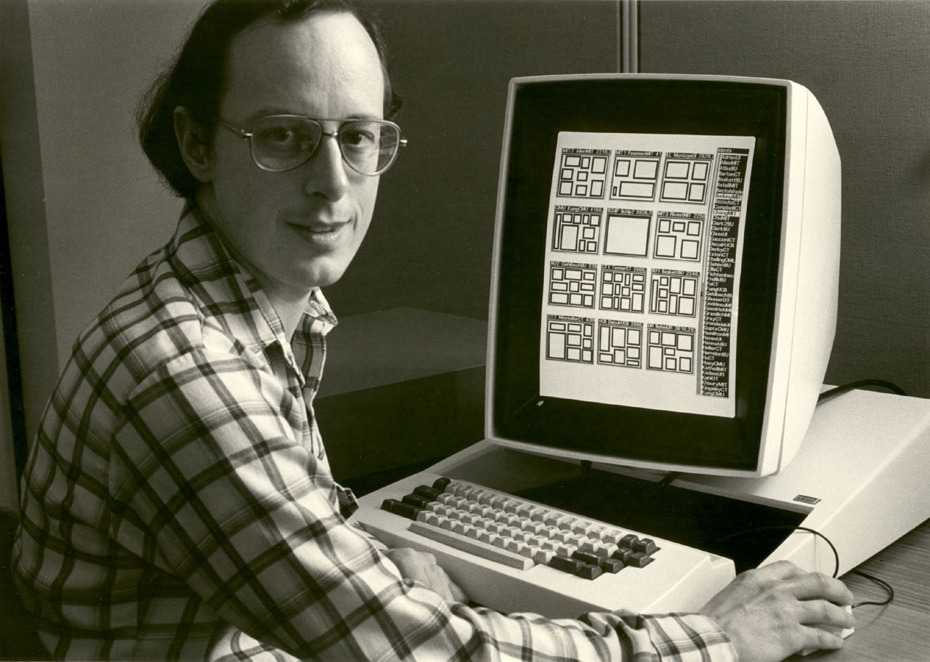
Alan Bell, architect of the prototype MPC software system, overseeing the final merge and die-layout planning of MPC79 projects, Xerox PARC, December 4, 1979.

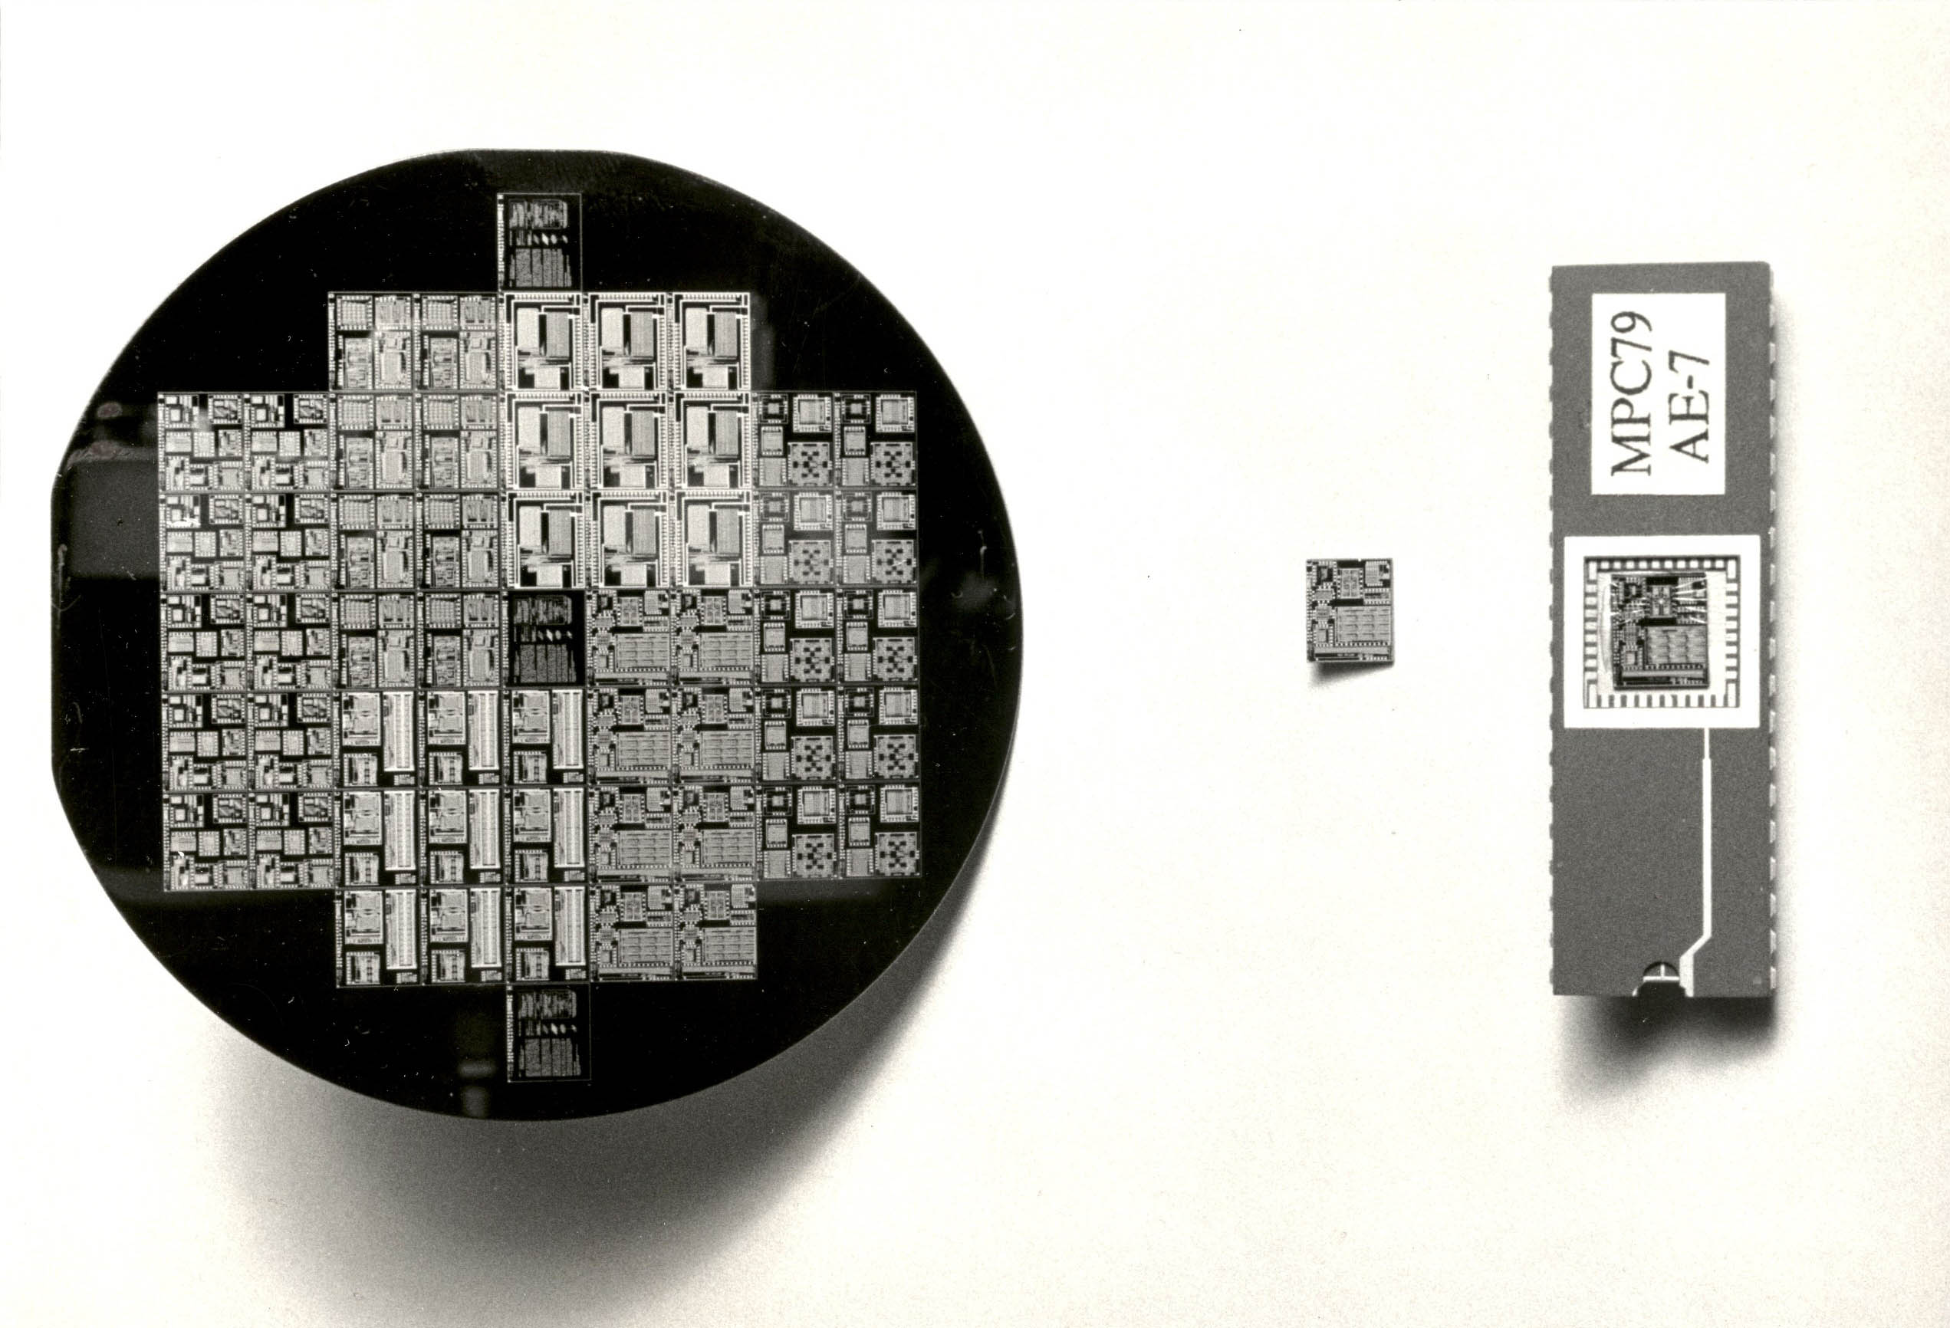
MPC79 wafer type A, along with packaged and wired-bonded project-chip AE-7,
January 2, 1980.

