* Copyright © IEEE 2012. A commentary published by the IEEE; posted online with permission. Citation: Chuck House,
“A Paradigm Shift Was Happening All Around Us”, IEEE Solid State Circuits Magazine, VOL. 4, NO. 4, FALL 2012, pp. 32-35.
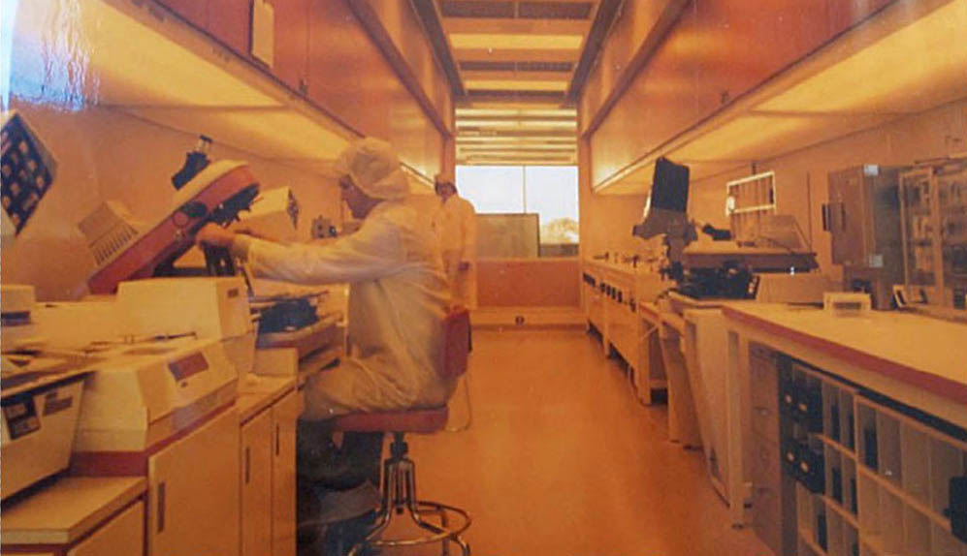

A Paradigm Shift Was Happening All Around Us*
By Chuck House

Thankfully, Ridley Scott’s brilliant Super Bowl ad, proclaiming that 1984 won’t be like 1984, heralded a Golden Age of Electronics instead of George Orwell’s dyspeptic scenario. Apple’s Macintosh debuted, Hewlett-Packard and its new LaserJet printer set record sales and profits for Silicon Valley companies, and I met Lynn Conway when we both joined the IEEE Spectrum Advisory Board.
Although Conway was a bit shy and had held back from the limelight, I already “knew” her. As HP’s Corporate Engineering Director, my job was to “know” the Valley. Operating a prototype Macintosh six months prior to introduction, I’d sparked Tom Whitney’s Summerhill Partners’ angel round that was the initial funding for Aldus Corporation and Pagemaker. I‘d compared views with Xerox PARC’s Warren Teitleman, both a Caltech classmate and a neighbor (with an Alto and then a Dorado by his home swimming pool). Warren and I had both known Carver Mead for 25 years. Mead was my senior advisor, urging me to join HP in 1962. By 1975, Mead and Conway were collaborating at PARC.
But I really knew Conway because of “the book” and the subsequent Electronics cover Award of Achievement in October 1981 [1]. Electronics, perhaps the most prestigious trade magazine at that time, had honored Intel’s founders, Bob Noyce and Gordon Moore, in their inaugural award in 1974; they’d singled out my Logic State Analyzers in 1977 (Figure 1) [2]. I’d joked with Mead that this was the first time I’d beaten him; he reminded me that he’d done the calculations for Gordon and even facetiously said the name “Moore’s Law” could have been “Mead’s Law”—he winked that he’d “won twice.”
The book—Introduction to VLSI Systems [3]—was a landmark. Simplistic histories of Silicon Valley and the Personal Computer Revolution focus on the hobbyist Homebrew Computer Club, the youthful Steves (Jobs and Wozniak), with a Gary Kildall vs. Bill Gates footnote. But the paradigm shift that enabled Apple’s and Microsoft’s emergence had vital antecedents that have largely remained obscure. Conway’s role there, while crucial, has often seemed “behind the scenes” to outside observers.
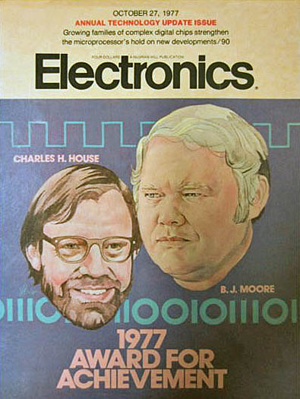
FIGURE 1: Electronics 1977 cover, with the Award of Achievement for Logic Analyzers. (Courtesy of Chuck House)
The second annual IEEE Workshop on Microprocessors (now called the Asilomar Microcomputer Workshop, or AMW) was held Wednesday–Friday, April 28-30, 1976, near Monterey, California [4]. Arriving the night before from HP Colorado Springs, I knew few of the ninety-four attendees. Espying Carver Mead, my college senior advisor, across the room in the buffet line, I joined him and six other ex-students at a dinner table. With a glazed look, Carver intoned that he recalled each of us.
AMW was the most successful of four private invitation IEEE design workshops that arose to discuss these presumptuously named ‘microcomputer’ integrated circuits. Authoring the Electronics May, 1975 article: “Engineering in the Data Domain Calls for a New Kind of Digital Instrument” got me invited to AMW’s 2nd workshop to describe the philosophy behind HP’s new Logic State Analyzers, which were tools analogous to oscilloscopes to give digital designers insight for using these complicated chips [5].
My Wednesday evening talk described tools that enabled a very different design methodology—Algorithmic State Machine design (ASM)—using Lyapunov state-variable mathematics, and derivative techniques pioneered at HP by Chris Clare and Dave Cochran for the spectacularly successful handheld scientific calculators (e.g., HP 35) [6].
My point: circuit design was no longer an element-by-element issue, but a question of “state flow” at lots of nodes—the sequential “words” of registers rather than the voltages of device pins. In effect, it argued that electronic voltages, whether analogic or switched, would “lose out” to software instructions, and “data states.” Systems would be designed and analyzed for proper state sequencing rather than analogic signal distortion or digital switching times.
I’d have done fine if I had left the See’s Candy POS terminal example out of the discussion, but I got carried away with case studies we knew from selling Logic Analyzers that were alien to this sophisticated assemblage. Four-bit microprocessors—the Intel 4040, for example—were “toys” to this group, and I didn’t know any better. In response to questions, though, I was able to describe our dedicated 8080 “personality module” for a forthcoming logic analyzer, just as an HP colleague tried to “shush” me.
When I finished, Carver was the first person to the podium, exclaiming, “NOW I REMEMBER YOU.”
He excitedly explained that our concepts of data domain (versus the traditional time domain or frequency domain methods taught to all electronic engineers) fit perfectly with some work he was doing. He asked to borrow my transparency foils, and proceeded to sketch something he called “the tall thin man” methodology for transistor layout. The room was mesmerized.
I’d been lucky at CalTech to be in Richard Feynman’s first freshman lectures with handwritten notes; this scene repeated at AMW2 as people asked how they could get copies of these new ideas. Mead said that he and Lynn Conway over at Xerox PARC were preparing some notes, which he might send electronically. Electronically? Yes, he said, if you have access to an ARPANET node. Some in the room nodded; others looked quizzical. The electric atmosphere of the evening is still etched in memory.
I’d already seen the power of pre-publication books. Clare’s insightful ASM methodology text, Designing Logic Systems Using State Machines, swept through the HPdesign community (Figure 2) [7]. Stanford’s electrical engineering department was not so sanguine, however, canceling Clare’s course in 1974, saying that “it is a little bit too unconventional” [8]. Stanford preferred Quine-McCluskey minimization techniques. Fittingly, Mead’s Caltech colleague Ivan Sutherland prepared a Scientific American article (1977) [9] about the challenge microelectronics posed to computing theory and practice, noting that since most of a chip’s surface was occupied by “wires” (conducting pathways) rather than “components” (transistors), decades of minimization theory in logic design had become irrelevant [10].
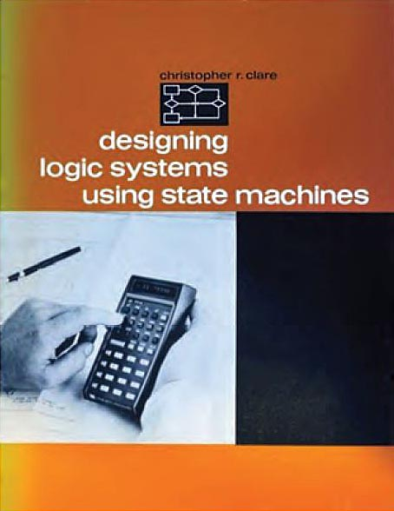
FIGURE 2: Chris Clare’s book: designing logic systems using state machines. (Courtesy of Chuck House)
AMW would “make history”—as industry veteran Ted Laliotis noted thirty years later: “the intentional lack of written proceedings and the exclusion of general press representatives was perhaps the most distinctive characteristic of AMW that made it so special and successful. This encouraged the scientists and engineers who were at the cutting edge of the technology, the movers and shakers that shaped Silicon Valley, the designers of the next generation microprocessors, to discuss and debate freely the various issues facing microprocessors. In fact, many features, or lack of, were born during the discussions and debates at AMW. We often referred to AMW and its attendees as the bowels of Silicon Valley...” [11].
AMW would feature many key contributors to this new paradigm during the first six years. Intel’s Sterling Hou extolled the Intellec 8 for developing 4004 and 8008 code at AMW1; he shared the stage with me at AMW2, describing the Intellec MDS to assist Intel 8080 microcomputer designers. The “toy” Intel 4004 had 2,300 transistors and a clock speed less than 1 MHz—its largest usage by 1976 was in a grocery clerking tool built by MSI Data of Costa Mesa for Alpha Beta Grocery Stores on a whim.

Moore’s Law from 1965 predicted a bright future, but in spring 1976, this august body was still profoundly skeptical. No one would have believed that a Pentium 4 chip with a billion transistors and a gigahertz clock speed would exist twenty-five years later, let alone sell for a thousand dollars.
An uneventful AMW3 was followed by AMW4 in 1978, which featured Charlie Bass, Dave Farber, Gary Kildall, Bernie Peuto, Ken Bowles and Len Shustek among others. A strong Berkeley contingent showed up for AMW5, with Alvin Despain as Chair, and Dave Patterson, Carlo Séquin and Dave Hodges presenting alongside Nick Treddennick (Motorola 68000), and Intel’s Ted Hoff.
The real excitement at AMW5, however, was the last session on Friday, May 25, 1979, entitled “New Directions and Architectures.” Forest Baskett, newly arriving at Stanford from Xerox PARC, reviewed the extraordinary results of nineteen projects in Lynn Conway’s MPC78 course at MIT. Conway had written that: “I sent the final student design files to PARC via the ARPANET on December 6, 1978. Lyon and Bell then merged the 19 projects into a single multi-project chip CIF file, converted it to Mann PG format and had masks made by Micro Mask….In this first phase of an important collaboration with Pat Castro at Hewlett-Packard, wafers were fabricated at her Integrated Circuit Processing Lab (ICPL) at nearby HP Research using a 6-micron (λ =3 μm) silicon-gate NMOS process (Figures 3, 4). Everything went off without a hitch, and the packaged chips were shipped back to M.I.T. on January 18, 1979” [13]. I’ve wondered why Conway hadn’t presented the work; colleagues recall just that AMW “was invite only.”
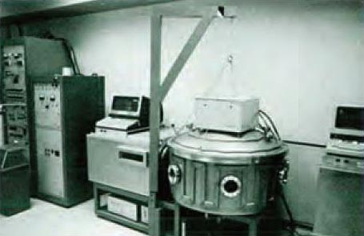
FIGURE 3: Computer-controlled plasma system at HP’s ICPL. (Courtesy of Hewlett-Packard [12])

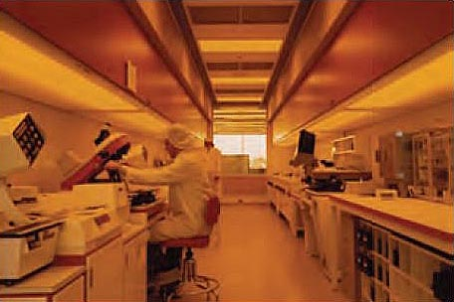
FIGURE 4: Fabrication processing line at HP’s ICPL. (Courtesy of Pat Castro)
Conway next fashioned an even more ambitious multi-university program—MPC79. The first session of AMW6 featured her bold initiative as “Special Purpose Building Blocks,” chaired Wednesday April 23, 1980 by Carlo Séquin, described by Carver Mead, Jim Clark, Glenn Krasner and Dick Lyon. The MPC79 chip set contained 82 design projects from 124 designers at 12 universities, spread across 12 die-types on two wafer sets. Astoundingly, turnaround time from design cutoff to distribution of packaged chips was only 29 days, again using Hewlett-Packard’s Palo Alto research fabrication facility. Conway’s proud assessment: “We’d done the impossible: demonstrating that system designers could work directly in VLSI and quickly obtain prototypes at a cost in time and money equivalent to using off-the-shelf TTL” [14].
Significant chips were built in the MPC79 “run,” including Jim Clark’s Geometry Engine that spawned Silicon Graphics Corporation. Substantial interest surfaced at Caltech, MIT, Berkeley, and Stanford—enough that Pat Castro and her colleagues at HP reluctantly had to “pull the plug” on opening their facility to universities, citing their industrial priority. Castro says today: “Jim Gibbons at Stanford was really offended when I told him ‘no’.” Gibbons acknowledges that this action stimulated his decision to build Stanford’s CIS (Computer Integrated Systems) lab; he further states that Lynn Conway, from his perspective, was the singular force behind the entire foundry development that emerged.
Clearly a new design paradigm had emerged—rendering discrete circuit design as irrelevant as Quine-McCluskey minimization rules. Importantly, imaginative support in terms of infrastructure and idea dissemination proved as valuable as the concepts, tools, and chips. “The electronic book” and the “foundry” were both prescient and necessary, providing momentum and proof points.
Castro, the first woman engineer hired by Fairchild Semiconductor, built the world’s first three-inch wafer fab facility for HP in 1975, pioneering a way to prototype multiple processes and designs. Her supervisor, Merrill Brooksby (Figure 5), who had built HP’s first IC fabrication facility in 1967, supported Castro’s leadership for this shop because of the breadth of HP’s scientific instrumentation requirements. The dedication and willingness of Castro (Figure 6) to work with universities was vital to produce the resultant student-designed wire-bonded chips in Conway’s MPC program.
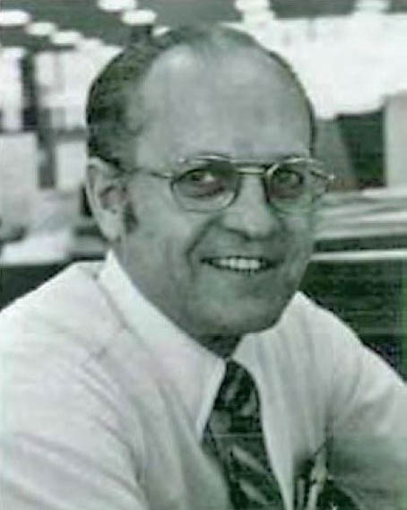
FIGURE 5: Merrill Brooksby, HP Corporate Design Aids Center director. (Courtesy of Hewlett-Packard [15])
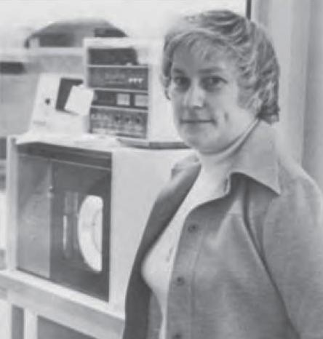
FIGURE 6: Patricia Castro, HP ICPL director, in 1977. (Courtesy of Hewlett-Packard [16])
The resultant methods would convulse an industry—but fame would accrue to the people who built the products using the chips, rather than to those who did the incredible breakthroughs to create the methods and even the chips themselves.
Paradigm shifts seem to be universally resisted—this one was no different. Virtually all mainframe and minicomputer companies (ironically, even Intel leadership), struggled to comprehend. Hewlett-Packard’s wildly decentralized organization allowed some individuals—Merrill Brooksby and Pat Castro in the IC lab; Chris Clare in calculators; and my team in the logic test business—to chase the new paradigm. But even at HP, conventional wisdom prevailed in most divisions. Moreover, Castro’s lab was “taken out of commission” for such industry-university experiments, when the volume of processing requests from Stanford, CalTech, and Berkeley among others escalated on the heels of MPC 79.
It took nearly another decade before commercialized EDA design tools and silicon foundries emerged to support industrial designers in the way that Conway’s MPC79 sponsored. In retrospect, Conway’s dedication and insights irrevocably altered extant companies while fueling a worldwide digital electronics cornucopia. We are all beneficiaries.

About the Author
Chuck House, an IEEE and ACM Fellow, Director of InnovaScapes Institute, was recently Chancellor of Cogswell College, Sunnyvale, CA, and Executive Director of Media X @ Stanford University after a long career at Hewlett-Packard and Intel. Author of The HP Phenomenon, his work has been honored by CNN (Top 25 products of past 25 years), Smithsonian (200 Wizards of Computing), Electronics Design (Top 50 products of 20th century), and the HP Medal of Defiance. A past vice president of IEEE, he also was an ACM president.

References
[1] Waller, Marshall L., and H. Wolff, “The 1981 Achievement Award: For optimal VLSI design efforts, Mead and Conway have fused device fabrication and system-level architecture”, Electronics, (54:21), October 20, 1981, cover and pp. 102–105.
[2] “The 1977 Electronics Award of Achievement,” Electronics, (50:22), October 27, 1977.
[3] Mead, Carver and Lynn Conway, “Introduction to VLSI Systems,” Addison-Wesley, Reading, MA, 1980.
[4] Agendas for the first thirty years are at http://www.bswd.com/AMW-35thWorkshopBooklet-SingleSidedVersion.pdf.
[5] House, Charles H., “Engineering in the Data Domain calls for a new kind of digital instrument,” Electronics, (48:9), May 1, 1975, pp. 75–81.
[6] On April 14, 2009, the IEEE Milestone in Electrical Engineering award for the HP 35 was presented by the outgoing president of IEEE, Dr. Lewis Terman. Terman was one of Mead’s seven ex-students at the 1976 Asilomar dinner table.
[7] C. Clare, Designing Logic Systems Using State Machines, McGraw-Hill, NY, 1973.
[8] C. House and R. Price, The HP Phenomenon, Stanford University Press, 2009, p. 260.
[9] Sutherland, Ivan and Carver Mead, “Microelectronics and Computer Science”, Scientific American, November 1977, pp. 210–228.
[10] Conway, Lynn, “IBM-ACS: Reminiscences and Lessons Learned from a 1960’s Supercomputer Project”; in: C. B. Jones, J. L. Lloyd, (Eds.), Dependable and Historic Computing: Essays Dedicated to Brian Randell on the Occasion of his 75th Birthday, Springer-Verlag, Berlin, 2011, pp.185–224.
[11] T. Laliotis, Commemorative Booklet for the 35th Asilomar Microcomputer Workshop, April 15–17, 2009.
[12] Hewlett-Packard Journal, June 1981, 32:6, p. 30.
[13] Conway, Ibid.
[14] Conway, Ibid.
[15] Hewlett-Packard Journal, Ibid.
[16] Hewlett-Packard Reporter, November 1977, p. 34

