#UNIT 2017 URLs

#UNIT 2017 CONNECTING UNICORNS: The Global LGBTI Tech & Science Conf. MAY 6, 2017, BERLIN
http://connecting-unicorns.com/

https://www.facebook.com/events/1593504910976633/
https://twitter.com/unicornsintech?lang=en
https://www.eventbrite.de/e/unit-2017-the-global-lgbti-tech-science-conference-tickets-27489714476
http://www.washingtonblade.com/dc-events-calendar/unit-2017-global-lgbti-tech-science-conference/2017-05-06/
http://twibbon.com/support/i-am-a-part-of-unit-2017
https://eventseeker.com/event/may-6-2017/226716947-unit-2017-the-global-lgbti-tech-science-conference-berlin

Venue: Schwuz, Rollbergstrasse 26, Berlin, 12053
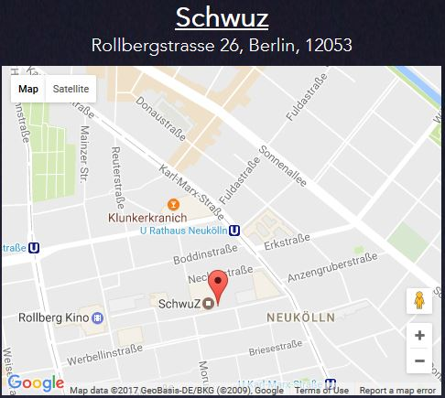
http://travelsofadam.com/city-guides/berlin/#hotels

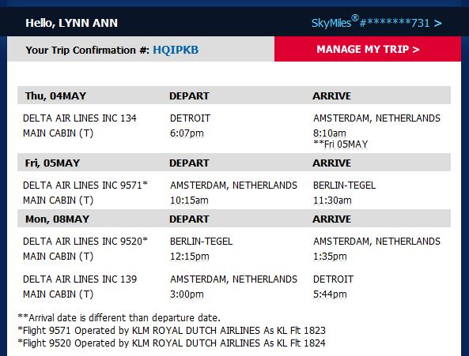

http://www.berlin-airport.de/en/index.php
https://www.european-traveler.com/germany/transportation-to-berlin-tegel-airport-txl/

Mercure Hotel Berlin Tempelhof Airport
http://www.reservations.com/hotel/mercure-hotel-berlin-tempelhof-airport

