“What Words Will You Leave to Guide Them?”
Commencement Address & Quoem by Lynn Conway
University of Michigan, Ann Arbor, Dec.16, 2018
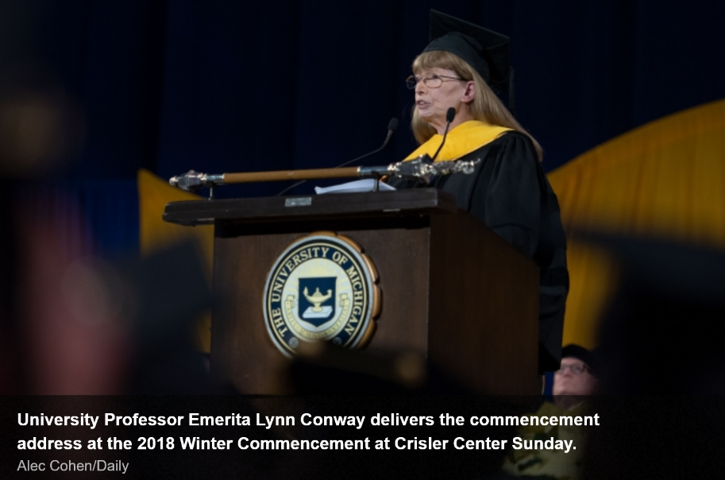

President Schlissel, Provost Philbert, Regents and Faculty Members . . . what a joy it is to join you on this very special occasion!
I’m deeply moved by the honor you’ve given me . . . and thrilled, in turn, to help you honor the many students receiving degrees here today.
And to all you amazing students: This is YOUR DAY to celebrate, enjoy, and build treasured-memories with friends, families and loved ones . . .
But before the celebrations begin, let’s take a few minutes . . . and together visualize the seas you’ll soon be sailing. Especially since you’re embarking in an era of accelerating social change, where our evolving technologies connect and empower us in previously-unimagined ways.
In the “Social Age” ahead, waves of spontaneous shared-team-consciousnesses will rapidly arise, evolve and interact. While contributing inside (and across mosaics of) such-teams, you’ll encounter increasingly-diverse, often conflicting, ways of being . . . giving ever-deeper meaning to the old maxim “Consistency is for Small Minds”.
By focusing on building your social-capital as learners, contributors, innovators, leaders and explorers . . . instead of merely seeking money, possessions, formal positions and the trappings of power . . . you’ll expand your social-agility, and your life-long opportunities to team-up with cool people, go exploring, have exciting adventures, and leave tracks behind.
And by embracing . . . rather than fearing accelerating social change . . . you’ll experience a most-wondrous effect: “You’ll live far further into the unfolding techno-social-future than you ever dared dream!”

Now, that’s all well and good . . . But you ask: How can WE stay out on the fronts of those waves . . . especially when seeing others slip back over their crests . . . and fall into the backwaters behind?
From the perspective of 80 years of age . . . I realize that “my guides” have been sets of “special words” left by earlier pathfinders . . . people whose life-stories have deeply touched me . . . and whose words resonated ever-more-clearly as I aged. I’d like to share some with you. For example:
Winston Churchill gives us a compass for our life-journeys when he says,
“The farther backward you can look, the farther forward you can see.”
And as Steve Jobs observes,
“Your time is limited, so don't waste it living someone else's life.”
Grace Hopper reminds us, as we’re about to set sail, that
“A ship in port is safe, but that’s not what ships are built for.”
And as ‘The Great One’ Wayne Gretzky says,
“You miss 100 percent of the shots you don't take!”
Then too, as social philosopher Eric Hoffer reflects:
"In a world of change, the learners shall inherit the earth, while the learned shall find themselves perfectly suited for a world that no longer exists!"
So, do be careful! Don’t just build ‘expertise’ to rest on as time passes. As B. B. King keenly observed: “The beautiful thing about learning is nobody can take it away from you!”
Thus oriented, pay heed to Intel’s Co-Founder Bob Noyce and:
“Go off and do something wonderful.”
During dangerous voyages, be stoically realistic, yet passionately persistent, for as historian and activist Bertha Calloway reminds us:
“We cannot direct the wind, but we can adjust the sails.”
In extrema, as gonzo journalist Hunter S. Thompson coolly observes,
“When the going gets weird, the weird turn pro!”
That can get pretty-wild, but you can come to love it. As Kurt Vonnegut says,
“I want to stay as close to the edge as I can without going over. Out on the edge you see all kinds of things you can't see from the center.”
Sometimes, you can even step across the edge, my own perspective being:
“If you want to change the future, start living as if you're already there!”

In her poem “A Summer’s Day”, Mary Oliver poses perhaps the ultimate question:
“Tell me, what else should I have done? Doesn't everything die at last, and too soon? Tell me, what is it you plan to do with your one wild and precious life?”. . .
During your explorations . . . always mentor AND learn from the young ones who come after you . . . eager to learn the ropes and join your crews . . . for your fates are bound-up-together, in the same ships, atop a deep ocean.
Finally, thinking further ahead to when YOU are 80, what words will YOU leave to guide the young, and their children and grandchildren . . . as they nervously gear-up to surf the wondrous-waves of life’s unfolding experiences? . . . What words?
Then I remember ‘The Words’ . . . words left to us by the legendary French aviator and writer, Antoine de Saint-Exupéry:
“If you want to build a ship, don’t drum up people to collect wood and don’t assign them tasks and work, but rather teach them to long for the endless immensity of the sea.”
The chance to share these words with you, on YOUR very special day, means more to me than you can possibly imagine . . . and I wish you all good fortune in the adventures ahead!
GO BLUE!
