Links and Resources re U.C. Davis

Event Announcement
https://fri.ucdavis.edu/events/dr-lynn-conway-breakfast-panel-seminar
https://fri.ucdavis.edu/sites/g/files/dgvnsk4186/files/files/event/Lynn%20Conway_April%2025%20Save%20the%20Date.pdf

Event Registration
https://docs.google.com/forms/d/e/1FAIpQLSeyXKmiOK-W1sOOJ_Ht2Vdfp8C1_qfL_MquT46uuuRkKhkC_A/viewform

Contacts:
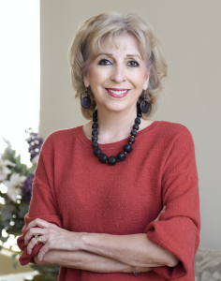
Linda P.B. Katehi, Chancellor Emerita
Distinguished Professor of Electrical and Computer Engineering
https://en.wikipedia.org/wiki/Linda_Katehi
https://faculty.engineering.ucdavis.edu/katehi/
katehi@ucdavis.edu

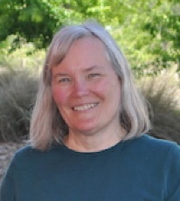
Linda Bisson, Professor Emeritus of Viticulture and Enology
https://biology.ucdavis.edu/people/linda-bisson
https://garamendi.house.gov/press-release/advancing-women-s-careers-and-dreams-conference-garamendi-experts-discuss-status-women
lfbisson@ucdavis.edu
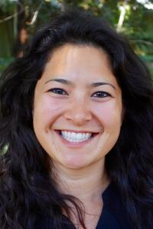
Sophie J Barbu, Program Manager for the UC Davis ADVANCE Program
https://ucd-advance.ucdavis.edu/profile/sophie-barbu
https://ucd-advance.ucdavis.edu/inclusive-campus-climate-initiative-stead-committee
sjbarbu@ucdavis.edu

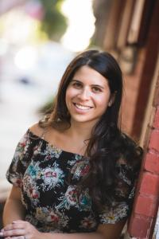
Kate Blumenthal, UC Davis ADVANCE Communications and Administrative Manager
https://ucd-advance.ucdavis.edu/profile/kate-blumenthal
https://www.linkedin.com/in/kate-blumenthal-6169a7139/
kblumenthal@ucdavis.edu

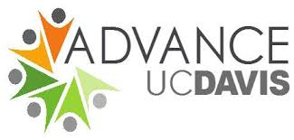

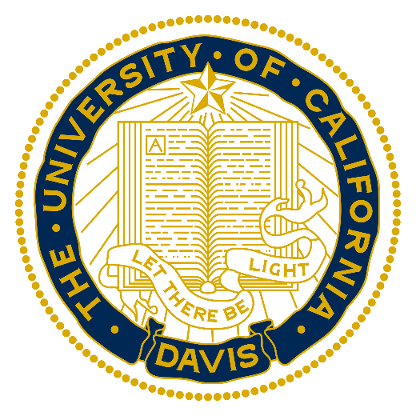
https://en.wikipedia.org/wiki/University_of_California,_Davis#/media/File:The_University_of_California

