Breakfast Panel:
“Finding Voice, Creating Space for Non-Dominent Voices”

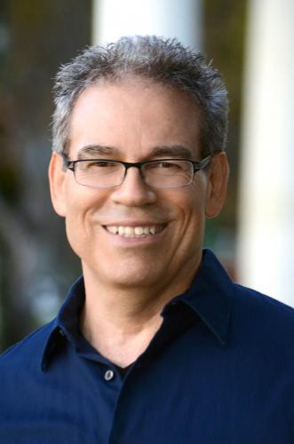
Moderator:
Steven Athanases
Professor and Dolly and David Fiddyment Chair in Teacher Education
https://ucd-advance.ucdavis.edu/profile/steven-athanases
https://www.linkedin.com/in/steven-athanases-18503018/


Eli Alston-Stepnitz
Ph.D. Student in Sociology at UC Davis
https://sociology.ucdavis.edu/people/eliatoz
https://www.linkedin.com/in/eli-alston-stepnitz-b1a1aa5/

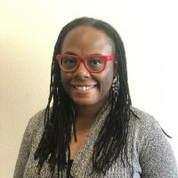
Devin Horton
Graduate Diversity Office: Science, Technology, Engineering and Mathematics (STEM)
https://hr.ucdavis.edu/people/devin-horton
https://www.linkedin.com/in/devinhorton/

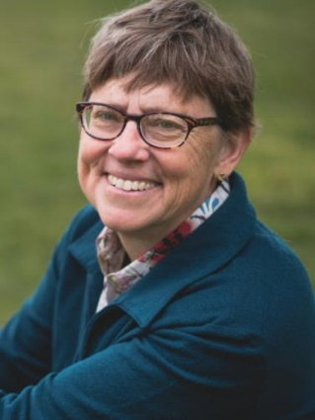
Professor Deb Niemeier
Dept of Civil and Environmental Engineering
https://faculty.engineering.ucdavis.edu/dniemeier/
https://education.ucdavis.edu/faculty-profile/deb-niemeier
https://its.ucdavis.edu/slide-show/its-davis-professor-deb-niemeier-elected-as-member-of-national-academy-of-engineering/

+ Lynn + Undergrad Student

