https://news.syr.edu/blog/2018/09/25/davis-named-interim-assistant-dean-for-inclusive-excellence-in-engineering-and-computer-science/
STEM

Davis Named Interim Assistant Dean for Inclusive Excellence in Engineering and Computer Science
Tuesday, September 25, 2018, By Matt Wheeler
Share
As part of the continued commitment to diversity, inclusion and student success in Syracuse University’s College of Engineering and Computer Science (ECS), Karen Davis ’83, G’91 has been appointed interim assistant dean for inclusive excellence. In this new position, she will oversee the college’s newly established Office of Inclusive Excellence—launching Oct. 1.
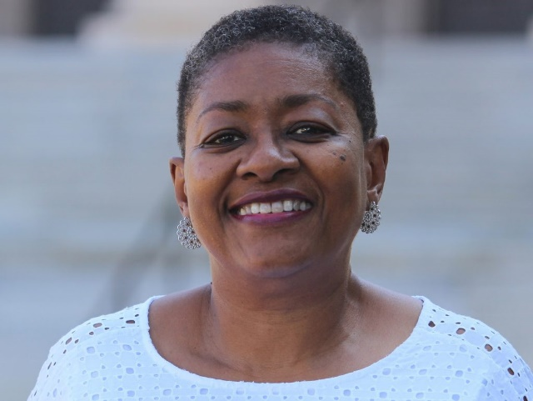
Karen Davis
Under her leadership, the Office of Inclusive Excellence will augment and integrate diversity, equity, and excellence within the college through education, research, dialogue, policy, and assessment. The office will house programs for student success and high-impact experiential programs; it will coordinate training and education for faculty, staff, and students; and its strategies will be informed by research and reporting—including regular assessment. Davis will also chair the college’s newly seated Inclusive Excellence (IE) Council. In its first year, the council is charged with completing a diversity audit and with partnering with InterFaith Works to draft and launch a dialogue.
“I am excited and honored to dedicate myself to enhancing our College’s culture of diversity, inclusion, and equity,” says Davis. “I ardently believe in the vision of the Office of Inclusive Excellence, and I am pleased to be in a position to move the needle in these critical areas.”
Dean Teresa Abi-Nader Dahlberg announced plans to establish the Office of Inclusive Excellence this summer. Its structure and programming are being informed in-part by the teachings of the National Inclusive Excellence Leadership Academy (NIXLA). Davis, Dahlberg and other key college leaders participated in NIXLA this past summer in an intensive, five-week session.
In its first major initiative, the Office of Inclusive Excellence is developing a Strategic Inclusive Excellence Leadership Program in partnership with InterFaith Works that uses dialogue to develop inclusive excellence leadership skills—crucial for enhancing campus climate and skills cited by employers as essential for leadership in today’s global, diverse and multicultural workforce. With guidance from the IE Council, the dialogue will be developed, piloted and rolled out over two years and will engage more than 500 faculty, staff and student leaders in dialogue—including administrators, teaching assistants and student leaders.
“In establishing the Office of Inclusive Excellence, it was imperative to appoint a strong and compassionate leader. Karen is a pillar of our college community and a longtime advocate of diversity in engineering and computing education and employment,” says Dahlberg. “I am thrilled that she has accepted this vital new role and look forward to all that we will accomplish through her leadership.”

