Hosts &Contacts for Syracuse University Lecture
March 26, 2019

 | Jean Brooks, Assistant Director, Office of Special Events  Work: 315-443-4631 / Cell: 315-256-1333 /  jabro101@syr.edu  (Ellen King, Executive Director, Office of Special Events)  Work: 315-443-4610 / Cell: 315-415-7195 / efking@syr.edu

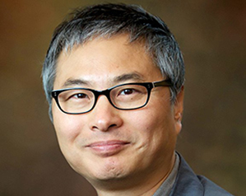 | Jae C. Oh, David G. Edelstein Professor for Broadening Participation, Department Chair EECS  https://engineeringonline.syr.edu/about/faculty-leadership/profile/jae-c-oh/ Work: 315-443-4740 / Cell:315-399-9647/  jcoh@syr.edu

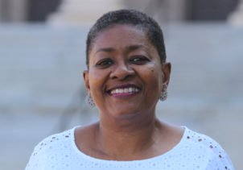 | Karen Machelle Davis, Interim Assistant Dean for Inclusive Excellence, College of Engineering & Computer Science  https://news.syr.edu/blog/2018/09/25/davis-named-interim-assistant-dean-for-inclusive-excellence-in-engineering-and-computer-science/  https://www.linkedin.com/in/karen-davis-su/ (1st)  Work: 315-443-2239 / Cell: 315-263-0183/  kmdavi01@syr.edu

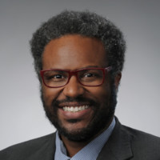 | khristian kemp-delisser, Director, LGBT Resource Center  https://news.syr.edu/blog/2018/02/20/khristian-kemp-delisser-01-named-lgbt-resource-center-director/  https://www.linkedin.com/in/doctorkaykaydee/ (2nd)  Work: 315-443-3983 / Cell: 860-805-4444/  klkempde@syr.edu

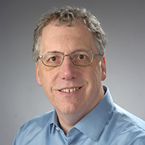 | Alan Middleton, Professor of Physics and Assoc Dean of Research and Scholarship, College of Arts and Sciences  https://www.linkedin.com/in/a-alan-middleton-01a154aa/ (2nd)  Work: 315-443-xxxx / Cell: 315-420-2539/  aamiddle@syr.edu

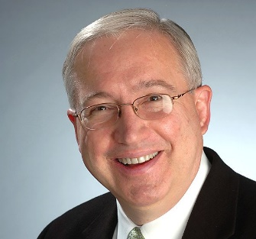 | Ed Bogucz, Associate Professor, Mechanical & Aerospace Engineering,  Executive Director of SyracuseCoE (CenterofExcellence) (BS, PhD, Lehigh)  https://www.linkedin.com/in/edward-bogucz-3219855 (3rd)  Work: 315-443-4445 / Cell: 315-251-5969/  bogucz@syr.edu

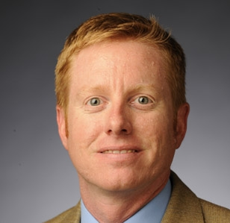 | Jonathan Neal Glass, Professor of Practice, Web Journalism and Innovation,  Executive producer of TheNewsHouse.com  https://newhouse.syr.edu/faculty-staff/jon-glass  https://www.linkedin.com/in/jonnglass/ (3rd)  jnglass@syr.edu

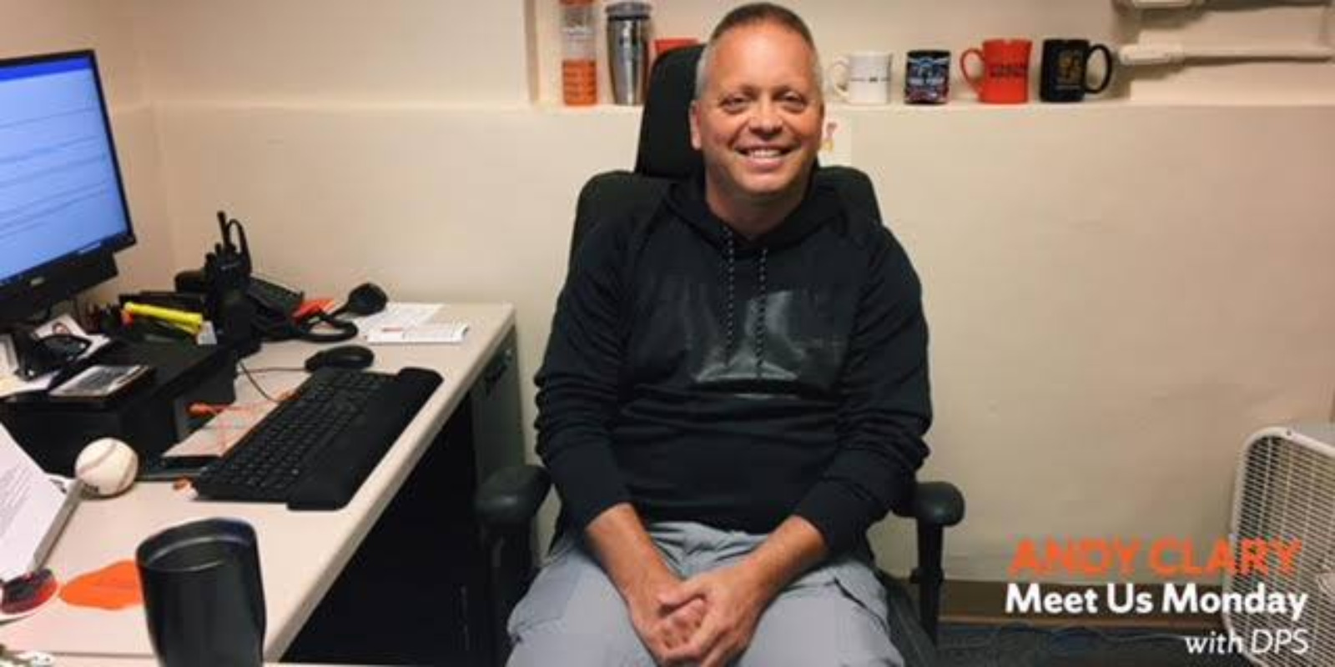 | Andrew L. Clary, Sergeant, DPS  alclary@syr.edu, Cell: 315.350.8299

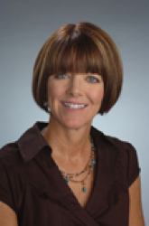 | Michelle Larrabee, Event Manager, Hendricks Chapel  (315) 443-2903, melarrab@syr.edu  (+ Dave Williams, Tech Support)

