IEEE Tech for Humanity Series @ SXSW
Speaker Information

Your Team  - Beth Surmont – IEEE Technical Activities co-producer – Sessions  - b.surmont@ieee.org, +1 732 562 3985  - David Stankiewicz – IEEE Technical Activities co-producer – Party & Meetups  - d.stankiewicz@ieee.org, +1 732 562 6085 | 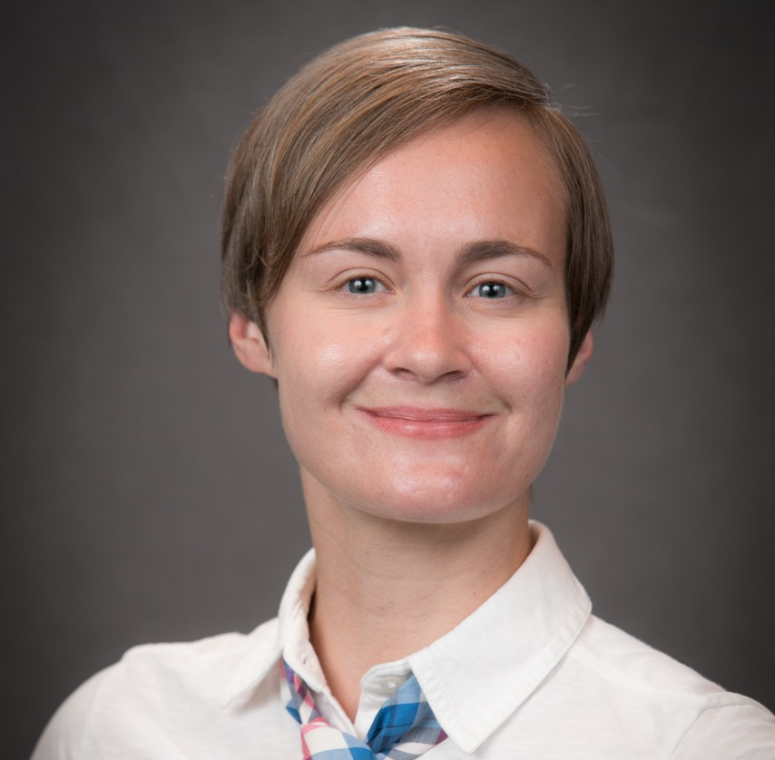
Additional IEEE Team  - Jeff Pane – IEEE Standards Lead  - Ann Townley – IEEE Marketing Lead & Exhibit Booth  - Mickey Young – IEEE Social Media & Exhibit Booth  - Mark Vasquez – IEEE Technical Activities  - Leigh Durst - Consultant  - Interprose – PR agency | IEEE Leadership  - Stephen Welby, Executive Director and COO  - Mary Ward-Callan, Managing Director, Technical Activities

Important Dates and Deadlines

Thursday 2 November | Tentative session date announced
November – December | 1st session call
Friday, 15 December | - Provide your W9 or W8 by December 31st in order to receive your stipend  - Please sign and return the IEEE Speaker Agreement  - Last day to decline IEEE complimentary membership
Thursday, 4 January | last day to enter 50-word bio and headshots to SXsocial
Thursday, 18 January | online schedule is posted and considered final
Mid-January | 2nd session call
Wednesday, 31 January | Provide to b.surmont@ieee.org:  - Guest pass information due (name and email)  - Airline reservation and any future updates  - Hotel confirmation if dates have changed  - Mobile Phone Number while onsite
Mid-February | Final session call
9-17 March | SXSW Interactive  - Saturday, 10 March – Speaker Breakfast  - Sunday, 11 March – IEEE Tech for Humanity Party

Important Speaker To-Dos
- Provide your W9 or W8 by December 31st in order to receive your stipend
- Sign and return the IEEE Speaker Agreement
- Confirm IEEE complimentary membership
- Provide guest pass information (name and email)
- Provide airline reservation and any future updates
- Provide hotel confirmation if dates have changed
- Provide mobile phone number while onsite
- Enter 50-word bio and headshots to SXsocial
- Participate in session planning calls
- Arrive day prior to session, wait until at least the day after to depart!
- Attend IEEE speaker breakfast if possible (if not ask for a remote briefing)
- 100% availability is requested the full day of your session
- Coordinate with IEEE on press / media interviews
- Promote the series (encouraged)

Things to know

Session Information
- Your session coordinator is your main point of contact.
- Your session coordinator will be responsible for scheduling prep calls, conveying and collecting needed information, and for coordinating the collection of any slides that may be shown.
- Your session coordinator will compile all speaker slides into a final deck that reflects the IEEE template.
- Sessions are 60 minutes long, and it is usually recommended to leave at least 15 minutes of Q&A.
- Audience interaction is highly encouraged.
- Room is typically set with a small stage, podium, table for panel sessions, a laptop, projector/screen, and both lavaliere and handheld microphones.
- Session attendance can vary, but it is usually between 100-300 people. IEEE sessions usually “sell out” quickly.
- The audience is usually 21-40 years old, mix of male and female, and extremely tech savvy and and future-looking.
- The audience comes to SXSW to learn about the future, and they are hungry for new ideas and discussions.
- Most of the IEEE sessions will be held at the Fairmont or the Austin Convention Center.
- Speakers are required to arrive for the green room call, one hour prior to session start. The green room is located in the same building as the session, but sometimes it is on a different floor.
- You will be escorted from the green room to your session by an IEEE producer and a SXSW producer.
- Green room calls are restricted, and only the speakers and the producer are allowed.
- It is simplest to plan to present from the SXSW-provided laptop. However, if you have a lot of videos embedded in your presentation it is possible to present from your own machine.
- 16:9 is the preferred aspect ratio.

IEEE Goals
- Extend IEEE brand recognition and show the organization as a place for innovators, creatives, technologists and young professionals.
- Highlight how the work of IEEE members is advancing technology for humanity and making a real difference in the world.

Press/Media
- There is a media suite onsite, in the Fairmont hotel.
- If you are contacted by press, please let your session coordinator know as soon as possible.
- IEEE’s PR agency, Interprose, will also be securing press opportunities.
- Only official IEEE spokespeople may speak on behalf of IEEE.
- In discussing your work, you should mention your participation in IEEE’s Tech for Humanity Series, and highlight your involvement with IEEE, or why you think IEEE is important.
- Be sure you have secured any needed permissions from your own organization.

Other Items
- There will be a speaker breakfast hosted by IEEE on Saturday, 9 March. You will have the opportunity to meet other speakers and IEEE leadership, as well as receive a press briefing. It is strongly recommended that you attend this breakfast if possible.
- Each speaker is provided with one day pass for the day of your session only. You will provide your coordinator with the name and email address of your guest by 31 January 2018.
- To show our appreciation, we will provide you with a a complimentary IEEE Membership (effective March 2018 through December 2018). We will process this on your behalf unless you choose to opt out.
  - For more information about IEEE membership, please visit:
http://www.ieee.org/membership_services/membership/welcome.html

IEEE Tech for Humanity Series
Series URL: http://tech-for-humanity.ieee.org/
(active in December)

KEYNOTE:
Quantum Computing
William Hurley, Chair IEEE Quantum Computing Group
Monday 12 March

FEATURED SESSION:
Regenerative Biology
Dean Kamen, Deka Research, FIRST® and ARMI
Sunday 11 March

FEATURED SESSION:
Extreme Bionics: The Future of Human Ability
Hugh Herr, MIT Center for Extreme Bionics
Aimee Mullins, Aimee Mullins Studio
Hans Georg Nader, Ottobock

A Hearable Future: Sound as Interface
Poppy Crum, Chief Scientist, Dolby Labs

Full Body Immersion: Future of Fun
Lou Pizante, COO, Two Bit Circus
Vince Kadlubeck, CEO & Co-Founder, MeowWolf
David Sprigner, CEO, Bodaborg

Binding Memory & Emotion: Science, Scent & Story:
Jacki Morie, Scientist, Inventor, RemniScent
Luca Turin, Technical Biophysicist, BSRC Alexander Fleming
Saskia Wilson-Brown, Founder, Institute for Art & Olfaction

Body Computing, Security & Human Safety
Dr. Leslie Saxon, USC
Michael Chertoff, Chertoff Group; Former Secretary, Deptartment of Homeland Security
Beau Woods, Atlantic Council

Clinical VR: Therapy with Promise & Potential
Skip Rizzo, Director of Medical Virtual Reality, USC

A Game Changing Shift in Control of Personal Data
Doc Searls, Harvard, Project VRM; IIW
Karen McCabe, IEEE Standards
Nikki Hickman, Inglish Jane Ltd.

Can We Create Consciousness in a Machine?
Glenn Zorpette, IEEE Spectrum Magazine
Christof Koch, The Allen Institute
Dave Chalmers, Australian National University
Susan Schneider, Institute of Advanced Study

A Roboticist, Ethicist & Novelist Walk Into a Bar
Steven Cass, Senior Editor, IEEE Spectrum Magazine
Lynne Parker, Associate Dean, University of Tennesee
Ryan Jenkins, Ethicist and Professor, Cal Poly
Robert Venditti, Writer, Top Shelf Productions

Algorithms, Unconscious Bias, and AI
Amy Nordrum, Associate Editor, IEEE Spectrum
Lynn Conway, Professor of Electrical Engineering and Computer Science, University of Michigan
Nita Patel, Founder and Chair, IEEE Women in Leadership International Conference

IEEE FUTURE OF THE HUMAN BODY MEETUP

IEEE WOMEN IN TECH MEETUP

IEEE YOUNG PROFESSIONALS MEETUP

IEEE TECH FOR HUMANITY PARTY
SUNDAY 11 MARCH
7-8 PM VIP MEDIA HOUR (INVITE ONLY)
8-10 PM PARTY

