SXSW Session Prep Teleconference Call
Wednesday, January 3, 11:00am – 12:00pm

Dial-In: 866 282 7366, Access code 637 851 341

Elisabeth “Beth” Surmont, Organizer; Senior Manager Strategic Programs at IEEE
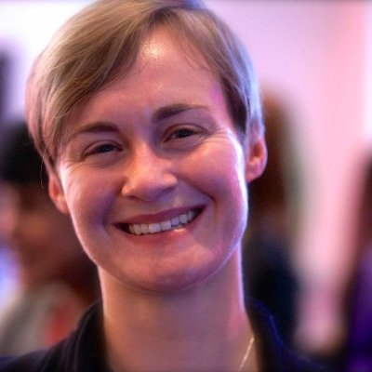
https://www.linkedin.com/in/bethsurmont/
View my Ignite Speech from the 2013 ASAE Annual Meeting:
https://youtu.be/J_OTGxd_gzE (“Smiley Guy”)

Amy Nordrum, Associate Editor, IEEE Spectrum
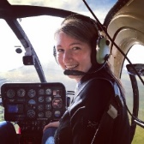
a.nordrum@ieee.org amynordrum.com
https://www.linkedin.com/in/amynordrum/
http://www.amynordrum.com/bio.html
https://youtu.be/i0hzGK0BJts (“On Taking Risks”)

Nita Patel, Senior Director, Engineering, L3 Technologies
Founder & Chair, IEEE Women in Engineering International Leadership Conference
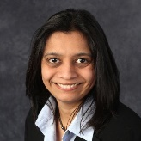
http://nitapatel.org/subpages/bio.html
https://www.linkedin.com/in/nitapatel73/
https://www.engineergirl.org/13472.aspx
https://ieeetv.ieee.org/ieeetv-specials/why-i-joined-nita-patel-p-e (“Why I Joined IEEE”)

Lynn Conway, Professor of EECS, Emerita, University of Michigan, Ann Arbor
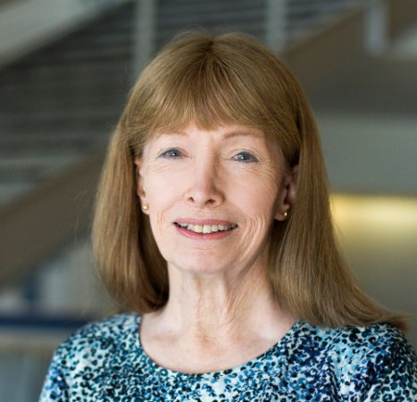
http://www.lynnconway.com
https://www.linkedin.com/in/lynnconway/
http://dme.engin.umich.edu/lynnconway/
http://ai.eecs.umich.edu/people/conway/Memoirs/VLSI/SSCM/VLSI_Reminiscences.pdf
https://www.youtube.com/watch?v=JBRCo1KDX_o (“Staying Sane”)

