ALERTS
This year the world woke up to the society-shifting power of artificial intelligence
https://qz.com/1156957/this-year-the-world-woke-up-to-the-society-shifting-power-of-artificial-intelligence/

OPTIMISM
Pioneer of Human-Machine Interaction Says AI Will Not Replace Workers - How the technology can empower people, not oust them
http://theinstitute.ieee.org/ieee-roundup/blogs/blog/pioneer-of-humanmachine-interaction-says-ai-will-not-replace-workers

PESSIMISM
Existential risk from artificial general intelligence
https://en.wikipedia.org/wiki/Existential_risk_from_artificial_general_intelligence
What can be done about our modern-day Frankensteins?
https://theconversation.com/what-can-be-done-about-our-modern-day-frankensteins-88856

SEARCHING FOR ADVANTAGE WHILE AVOIDING DANGER
OpenAI: Discovering and enacting the path to safe artificial general intelligence.
https://openai.com/
EX: Learning to Model Other Minds
https://blog.openai.com/learning-to-model-other-minds/
LOLA agents can discover effective, reciprocative strategies, in games like the iterated prisoner’s dilemma, or the coin game. In contrast, state-of-the-art deep reinforcement learning methods, like Independent PPO, fail to learn such strategies in these domains. These agents typically learn to take selfish actions that ignore the objectives of other agents. LOLA solves this by letting agents act out of a self-interest that incorporates the goals of others. It also works without requiring hand-crafted rules, or environments set up to encourage cooperation.

IEEE Just Published the First Draft Report on How to Make an ‘Ethically Aligned’ AI
https://futurism.com/ieee-just-published-the-first-draft-report-on-how-to-make-an-ethically-aligned-ai/
http://standards.ieee.org/develop/indconn/ec/ead_v1.pdf

HOW DOES IT WORK?
Machine Learning’s Growing Divide
http://semiengineering.com/machine-learnings-growing-divide/
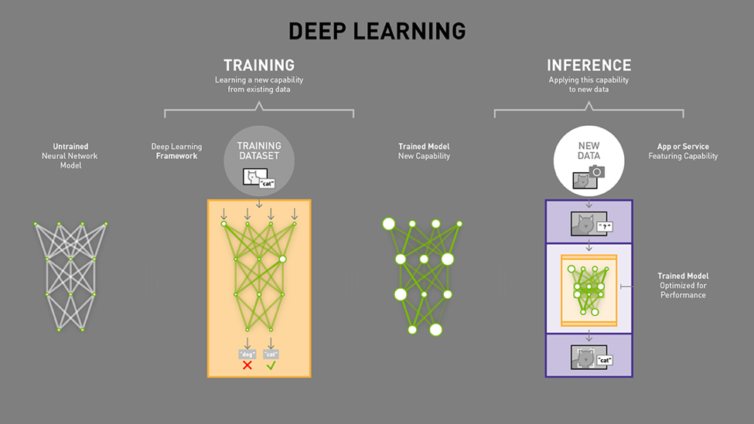

WHO’S TRAINING ALL THIS STUFF? NOT JUST ‘AI CODERS’.
Remember this idea? reCAPTCHA: Using Captchas To Digitize Books
https://techcrunch.com/2007/09/16/recaptcha-using-captchas-to-digitize-books/

Inside Amazon's clickworker platform: How half a million people are being paid pennies to train AI (via Amazon’s Mechanical Turk)
https://www.techrepublic.com/resource-library/downloads/inside-amazon-s-clickworker-platform-how-half-a-million-people-are-being-paid-pennies-to-train-ai-pdf-download/

Google’s AutoML lets you train custom machine learning models without having to code
https://techcrunch.com/2018/01/17/googles-automl-lets-you-train-custom-machine-learning-models-without-having-to-code/

BACKDROP FOR BRAINSTORMING:
Technically Wrong: Sexist Apps, Biased Algorithms, and Other Threats of Toxic Tech, by Sara Wachter-Boettcher
https://www.amazon.com/Technically-Wrong-Sexist-Algorithms-Threats-ebook/dp/B06XJBGPT9/

Brotopia: Breaking Up the Boys' Club of Silicon Valley, by Emily Chang
https://www.amazon.com/Brotopia-Breaking-Boys-Silicon-Valley-ebook/dp/B074LQKJJC/

