https://hackernoon.com/who-will-be-responsible-for-sinking-the-next-ai-titanic-37a6b801c843
Experimental Civics is a global consultancy dedicated to elevating communities through their engagement with technology. experimentalcivics.io
Mar 16, 2018

Who Will Be Responsible For Sinking the Next AI Titanic?

RMS Titanic departing Southampton on 10 April 1912

BuzzZZzzzzZZZzzzzzword drop: Artificial Intelligence (AI).
I saw this word appear everywhere around SXSW Interactive this year. But I think the most compelling takeaway was how we are still trying to make sense of AI and how it can help or hurt us.
“AI Titanic” was an excellent term shared in a panel discussion and it was not coined by me. Alas, I wish.
Lynn Conway, an American computer scientist, electrical engineer, inventor, and transgender activist spoke about the looming AI titanic that is about to happen.
“Back in the day of bridge engineering,” she explained. “The public knew who built the bridge and there was transparency. But there was also a clear culprit if things went wrong. With AI, the way that it is managed today…we have little to no public transparency...we’re going to have an AI titanic…things are bound to go wrong…that’s how we learn…but, we need to be careful.”
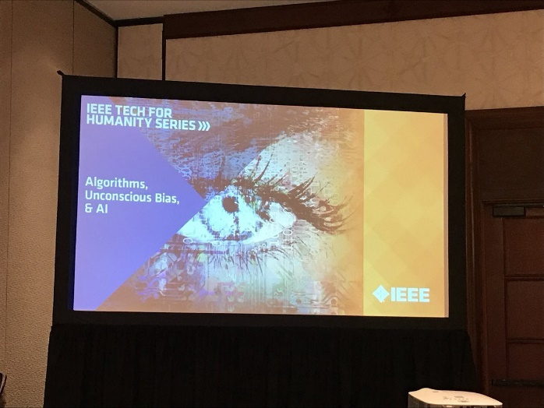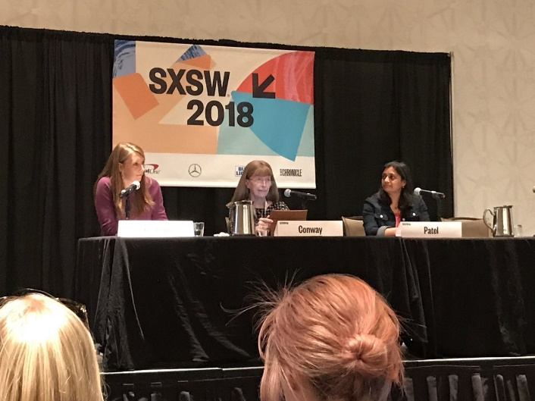
IEEE Tech for Humanity Series: Algorithms, Unconscious Bias + AI (Nita Patel and Lynn Conway)
I’m still digesting this panel and my notes…it was an intense discussion on the unconscious bias that we all hold, but the the greater importance of developers and designers holding themselves accountable to their social impact.

Really though…Who Holds the Responsibility?
For all my Black Mirror fans out there, a dystopian future for humanity especially with our current relationship with technology could be upon us sooner than we think.
I resent being dramatic…but the fantasy world depicted in the show could very much become our reality quickly and seemingly overnight. I look at how much change has happened in my existence already.
Mayor of London, Sadiq Khan, came to SXSW 2018 and shared multiple different, powerful messages.
A key takeaway here again was the theme of holding social responsibility.
“And the consequences, for example — something we’ve experienced on both sides of the Atlantic — where there is concerns about elections being interfered with through social media. There are concerns around fake news. There are concerns around how social media can be used to amplify messages of hatred and division. And I think tech companies, politicians, have a responsibility to respond to those concerns.” — Sadiq Khan
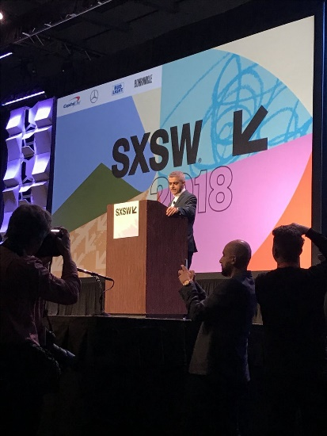
Credit: I took this! #FrontRow

Is it all doom and gloom? No.
I do want to leave on a more uplifting note about folks that are harnessing the power of AI for the benefit of humanity.
I sat in on a panel session about AI being used positively to address and end world hunger. With access to new, emerging technology and data, the ability of AI to accurately aid the work of providers on the ground is immense.
The panel was facilitated by Robert Opp, Director of Innovation and Change Management at the UN World Food Programme. The panelists offered diverse perspectives from their XPRIZE, Google, Gates Foundation and UN WFP backgrounds.
“85% of people affected by hunger are also the most vulnerable to disaster.”
I learnt about how current food assistance programs are being deployed around Africa and Asia, but more so, how AI multiples the efforts of one campaign worker to the masses.
“1/3 of humans globally suffer from malnutrition.”
As a humble and clueless human on the hurdles of current campaign workers, it was great to see so many organizations wanting to collaborate to innovate together and surface better solutions.
Listening to both the 10,000 and 10 ft level discussions was enlightening.
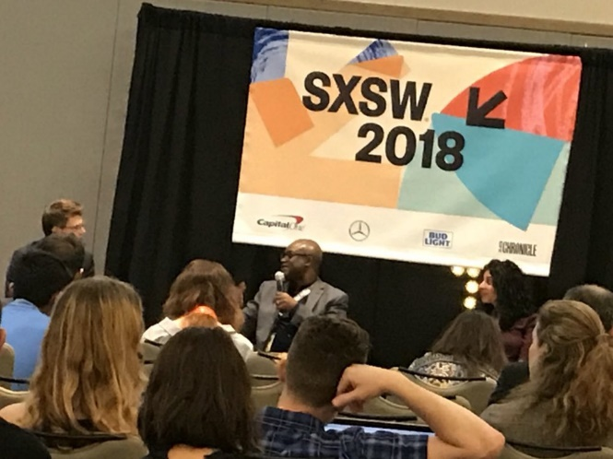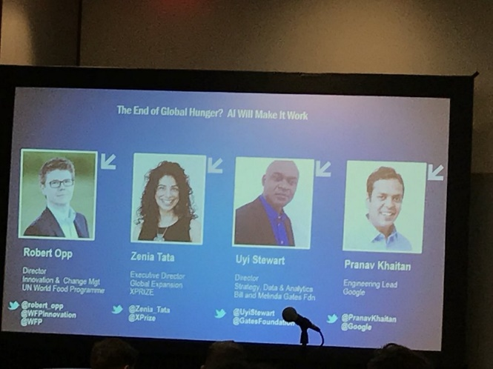

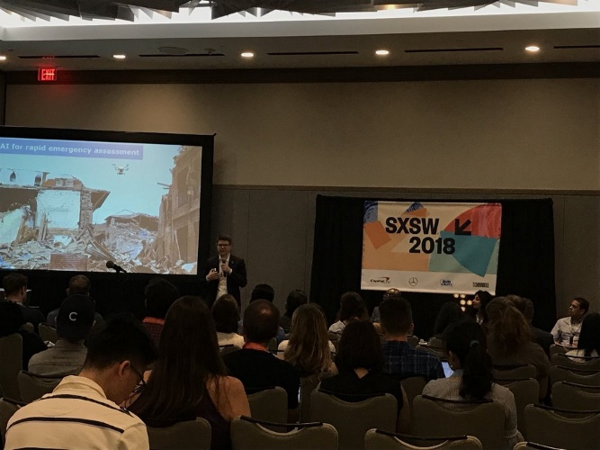
SXSW Session: The End of Global Hunger? AI Will Make it Work

But that still doesn’t solve the responsibility question…
I understand how we’re still learning.
I understand how we’re still building and evolving our relationship with technology.
I think all entities from governments to technology companies need to consider their larger social impact in the long term. When livelihoods are at stake, there needs to be a high level of social responsibility built in to the design based on the techno-socio behavior of users. What you’re developing may add dollars to your bank account, but it could cause greater harm when it breaks.
Back to Lynn’s reference, no bridge engineer designed and constructed their bridge without considering the flow of traffic, the weather patterns, the material properties…there’s a larger ecosystem of variables that need to be considered always.
They also owned when a bridge collapsed or failed. We need to rise and demand integrity when designing technology products for people. For our communities. For our humanity. For Jack Dawson.


So what are your thoughts? Share them below. These are my simple ramblings on the matter.

https://www.facebook.com/lynn.conway/posts/10155551210647712
https://twitter.com/lynnconway/status/979046160114552832

