Russia removes statue after Apple CEO comes out
AP 3:08 p.m. EST November 3, 2014
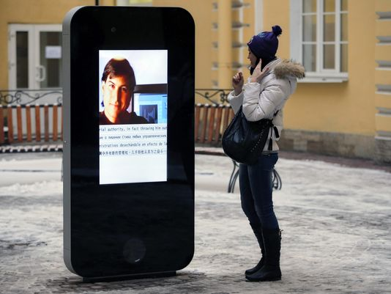

MOSCOW — A six-foot statue of an iPhone on a St. Petersburg university campus has been taken down in response to last week's announcement by the CEO of Apple that he is gay.
In a statement, authorizes described Tim Cook's revelation "a public call to sodomy". . . and said they were taking down the statue because it violated Russia's law protecting minors from homosexual propaganda.
Apple declined to comment on the removal of the statue, which featured former CEO Steve Jobs.

