Russia removes statue after Apple CEO comes out
AP 3:08 p.m. EST November 3, 2014
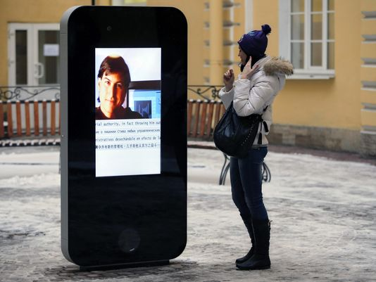
(Photo: Dmitry Lovetsky, AP)
193 CONNECT 49 TWEET 4 LINKEDIN 23 COMMENTEMAILMORE
MOSCOW — A six-foot statue of an iPhone on a university campus in St. Petersburg has been taken down in response to last week's announcement by the CEO of Apple that he is gay.
In a statement, ZEFS, which according to its website owns construction, advertising, and finance enterprises in St. Petersburg, describes Tim Cook's revelation "a public call to sodomy."
ZEFS said Monday it was taking down the statue because it violated Russia's controversial law protecting minors from homosexual propaganda. The law has been condemned by critics as a means of repressing sexual minorities in the country.
Apple declined to comment on the removal of the statue, which featured former CEO Steve Jobs.

