Avril Haines, The Least Likely Spy
By Daniel Klaidman, Newsweek, June 26, 2013
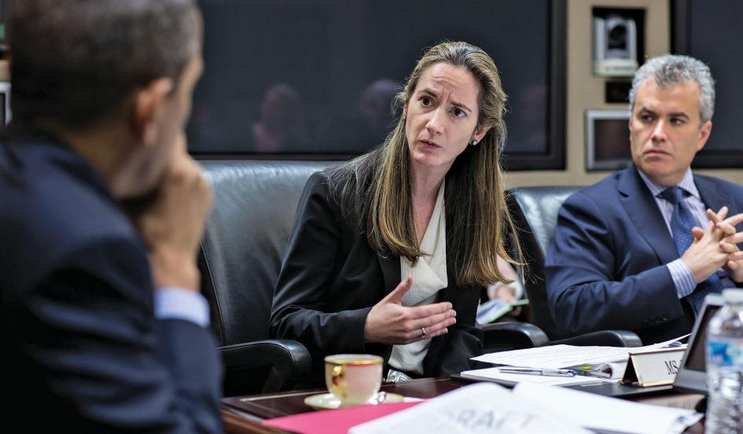
Pete Souza/The White House

The morning light was just breaking over Washington, D.C. At the White House, the early cleaning shift was already on the job. As Avril Haines walked through the quiet, darkened halls, she smiled and waved to a worker pushing a polishing machine, buffing the marble floors. It was 5:30 a.m. in mid May and Haynes was leaving work. She would return by 7, after a shower and change of clothes at her Capitol Hill home—and after picking up her habitual iced grande whole milk latte at the local Starbucks, where the baristas are on a first-name basis with her.
The past few weeks had been a grueling run for Haines, the top lawyer for the National Security Council. On this morning, she was laboring over the “playbook,” President Obama’s massively complex and bureaucratically contentious effort to reform the administration’s lethal drone program. But the truth is, it was only a slight departure from Haines’s typically relentless work routine. Since becoming the National Security Council’s legal adviser in 2011, she had been working on a wide array of highly complicated and legally sensitive issues—generally until 1 or 2 in the morning, sometimes later—that go to the core of U.S. security interests. Among them were the legal requirements governing U.S. intervention in Syria and the range of highly classified options for thwarting Iran’s nuclear program. All the while, Haines was sometimes summoned in the middle of the night to weigh in on whether a suspected terrorist could be lawfully incinerated by a drone strike.
Earlier this month, Obama selected Haines to be deputy director of the CIA, where she will serve under the new CIA director, John Brennan. In some respects, picking Haines made a lot of sense, given her national-security credentials and her well-known work ethic. But in another respect, it was a surprising choice. Ask around about Haines, and colleagues will often describe some character traits not usually associated with the CIA—or, for that matter, with rapid ascent inside the Beltway: a sweet personality, humility bordering on shyness, a deep empathy for others. “She may quite literally be the nicest person any of us have ever met,” says Deputy National Security Adviser Benjamin Rhodes, who has worked closely with Haines.
Haines’s journey reflects a flair for adventure, an appetite for risk, and an ability to overcome adversity.
That personality plays out every day in Haines’s interactions with top national-security officials in some of the most charged, high-stakes settings in government. She is known for her deferential style—Attorney General Eric Holder has occasionally admonished her to call him “Eric” rather than “Mr. Attorney General”—and tends to eschew the Washington habit of self-aggrandizement.
Even under normal circumstances, these traits might seem an odd fit at an agency tasked with deception and death. But they are especially surprising at a moment when the White House is attempting a far-reaching, and controversial, plan to rein in the CIA’s role in the war on terror. Haines, in many ways the ultimate outsider, will be working to reform a proud and deeply insular culture. To be sure, not every top CIA official of recent vintage has come from within the agency. But none has been quite like Haines. She will be the first woman to hold the deputy job at an agency that is still dominated by men. And she will be a lawyer in a culture of forward-leaning operators who fret about their hands being tied by risk-averse attorneys. Moreover, she has spent most of her career in government working at the State Department, an agency that does not typically share the same outlook as the CIA. (Indeed, when Obama tapped Haines for the CIA position, her nomination to be State Department legal adviser was pending before the Senate. It has since been withdrawn.)
Haines will be a lawyer in a culture of forward-leaning operators who fret about their hands being tied. Saul Loeb/AFP/Getty
There are plenty of jaded intelligence hands who see nothing but trouble ahead for Haines. Even some of her colleagues advised against taking the job. And Haines herself raised questions—at first—about whether the post was a good fit, before Obama coaxed her into taking it.
Yet there is a lot more to Avril Haines than simply a capacity for hard work and a kind exterior. “She is as caring and decent a person as I’ve ever had the blessing to work with, full stop,” says Denis McDonough, the White House chief of staff. “But we’re not going to make the NSC’s legal adviser somebody’s pushover.”
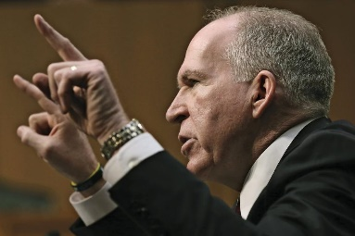
Indeed, Langley does not yet know about Haines’s unusual, even exotic, path to the pinnacle of the U.S. spy world. It is a twisting journey that reflects a flair for adventure, an appetite for risk taking, and an ability to overcome adversity. Haines, who is intensely private, has not shared key aspects of her truly unconventional personal story with even her closest colleagues, let alone her possible adversaries. Haines declined to be quoted for this article, but confirmed details of her life story. Taken together, they form a set of character-building experiences that suggest she should not be taken lightly at the CIA.
CIA Director John Brennan turned to Haines for virtually every major decision when he was the counterterrorism chief in the White House. Win McNamee/Getty
THE SOUND of the bell still haunts her.
Avril Danica Haines, an only child, was born in 1969 into a household alive with scientific inquiry and artistic fire. Her mother, Adrian Rappin, was a brilliant scientist who became a painter. Her father, Thomas Haines, was a biochemist and academic. Their apartment on Manhattan’s Upper West Side was what you might expect of an artist and professor. Their shelves overflowed with books; paintings covered the walls and piled up wherever there was space. Adrian was an intense and vivacious woman who burned the candle at both ends, throwing lively parties and then working feverishly in her studio when seized with fits of creativity. She was also exacting in her standards, both for herself and for those she loved. Avril’s father was a self-effacing and deeply empathetic man, who would ask his daughter every day whether she had done something kind for someone.
When Avril was 4, her mother’s health began to falter. She had chronic emphysema and later contracted avian tuberculosis, a bacterial disease she likely caught from pigeons nesting in the outside air conditioner. The combined illnesses severely diminished her lung capacity and confined her to a wheelchair or a medical bed in the large, high-ceilinged living room.
By the time she was 12, Avril took on the extraordinary responsibility of caring for her mother. Every day, Adrian had to be sealed for hours on end inside a head-to-shoulders respirator bag, a contraption with a vacuum pump to expand her lungs so that she could breathe. Later she had a tracheotomy, a surgical procedure that allowed her to breathe without using her mouth or nose. Sitting vigil every night, Avril learned to be hyperattentive to her mother’s needs. Medical emergencies at all hours were common; when they occurred, Adrian would ring a copper dinner bell and Avril would respond. (One night her mother’s tracheal tube came out and Avril had to insert it back through the hole in her neck, guided over the phone by a doctor. There was blood everywhere.) All the while, Avril was keeping up with her schoolwork and functioning on very little sleep.
Her mother died shortly before Avril’s 16th birthday. By then, with medical bills piling up, they had left their apartment and were moving around the city staying with different friends and relatives. Eventually, Avril moved in with a boyfriend.
Following high school, Avril—drained emotionally and physically—deferred college for a year and traveled to Japan. There, she enrolled in the Kodokan Institute, Tokyo’s elite judo school, and became a brown belt.
The next year, Haines started at the University of Chicago, where she studied theoretical physics. The male-dominated department was not welcoming to Haines. On her first day of class, a student questioned what she was doing there. “This is honors physics,” he said in a tone that insinuated she must have mistakenly entered the wrong classroom. Later during the semester, a professor took her aside to suggest that her mind might not be suited to physics. But she persevered and aced the class.
While in school, Haines took a job working for an auto mechanic in Hyde Park. She’d always been remarkably adept mechanically. As a kid in New York, she’d lugged home discarded TV sets and rewired their insides. In Chicago, she helped rebuild Subaru engines and restored old car parts retrieved from the auto graveyard.
During the summer between her sophomore and junior years, she was hit by a car while riding her bike. It was a serious accident, the effects of which cause her considerable pain to this day. While recuperating in the hospital and later during grueling traction sessions, she eased her pain by turning her mind to a dream she’d long harbored: buying an airplane and flying it to Europe.
The following summer, while back in New York, she enrolled in flying lessons in Princeton, New Jersey. She fell in love with her flight instructor, David Davighi, and not long after the course was over the couple traveled to Florida to hunt for a plane. They found a 1961 twin-engine Cessna 310 that needed work. Haines dove into rebuilding the plane’s aging avionics, and soon they were winging their way to Bangor, Maine, their launching point for Europe.
After outfitting the plane with extended-range fuel tanks, the couple took off late one summer afternoon, hoping to make it to England by the next day. But while flying over the North Atlantic, they began to take on ice. Soon they were losing altitude. The plane lost one engine, then the other. Gliding 1,000 feet over the ominous Labrador Sea, they considered the possibility of a daring water landing in between the waves. There was an eerie silence and a sense of being alone in the world.
Then, through the fog, they saw land. It was the edge of the Newfoundland coast, rocky and inhospitable. By now, one of the two engines had sputtered back to life. Miraculously, they spotted a small, isolated airport where they were able to land the plane. Socked in by bad weather, they were taken in for a week by the delighted residents of a remote town.
Though Haines and Davighi never made it to Europe, the harrowing experience had sealed their romance. Davighi followed Haines to Chicago for her last year in college, and in 1992 the two settled on moving to Baltimore, where he had found a job as a commercial aviator and she planned to pursue a doctorate in physics at Johns Hopkins. But fate and Haines’s flair for new challenges intervened once again. She and her husband learned about an old bar in the then-transitional neighborhood of Fells Point, which had been seized in a drug bust and was being auctioned off by the feds (the bar’s upstairs had been a whorehouse). The opportunity stoked another one of Haines’s dreams: ever since she befriended a curmudgeonly bookstore owner in her New York neighborhood, she had wanted to open her own independent bookstore and café.
They sold the plane, got a loan from the bank, and Haines threw herself into the project—down to doing the electrical work and plumbing herself. The store reflected her own deeply eclectic taste in books, including offbeat editions from small, independent presses. (For a period, the store hosted erotica and other literary readings.) Her hours—8 a.m. until 1 a.m., seven days a week—were grueling. But it was a labor of love.
The bookstore—which was called Adrian’s Book Café, after her mother—was in a rapidly gentrifying area, but one that was surrounded by tough neighborhoods and housing projects. (The police-drama Homicide: Life on the Streets was set there during the years that Haines owned the business.) Over time, Haines got more involved in the local community, working to build bridges between the upscale merchants and the residents of the projects. In the meantime, the business was winning awards and succeeding financially. The bank that made the original loan underwriting the bookstore urged Haynes to expand it into a chain.
But now her interests were rapidly shifting to community organizing. And she had begun to notice that the activists who knew best how to pull the levers of reform were lawyers. So she gave up the bookstore and applied to law school.
Haines began Georgetown Law School in 1998. Befitting the pattern of her peripatetic life, she soon moved in a new direction: she fell in love with international law and human rights. After law school, she clerked for a federal appellate judge and then in 2003 took a job as a lawyer in the State Department legal adviser’s office. (She and David also married that year.) Working in treaty affairs, Haines took an antiquarian’s interest in the history of agreements between nation-states and quickly demonstrated a facility for the intricacies of this area of international law.
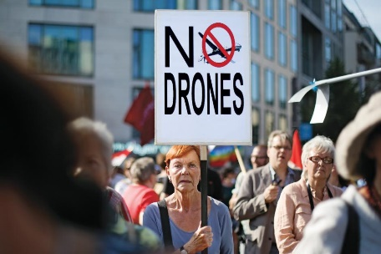
Haines was sometimes summoned in the middle of the night to weigh in on whether a suspected terrorist could be lawfully incinerated by a drone strike. Markus Schreiber/AP
As was so often the case throughout her career, Haines was noticed for both her industriousness and her collegiality. Not long after arriving at the Treaty Affairs Office, news broke that the Bush administration had entered into secret agreements with a number of countries in Eastern Europe allowing the CIA to set up black sites to hold and harshly interrogate suspected terrorists. Some members of Congress realized the clandestine accords were in violation of a law that required the State Department to notify the legislature of all agreements with foreign countries, secret or not. Haines and her colleagues discovered that, in fact, there were some 600 agreements dating back many years that had never been reported. Congress was livid. Haines plunged in to deal with the crisis, leading a team of lawyers in attacking the backlog, a labor-intensive process that involved writing a report for each agreement. They worked around the clock for weeks, pulling multiple all-nighters to get the job done.
Haines would also work in the Legal Adviser’s Office of Political Military Affairs, where she became steeped in the international laws of war. Then, following, a two-year stint working as a lawyer for the Senate Foreign Relations Committee under its then-chairman Joe Biden, she returned to State as head of the Treaty Affairs Office. But it didn’t take long before the White House noticed Haines’s mastery of international law. In 2011 she became deputy counsel to the president for national-security affairs, a role that placed her squarely at the center of law, security, and the government’s most sensitive military and counterterrorism operations.
LIKE MOST good government lawyers, Haines doesn’t advertise her policy preferences. She sees her job as laying out legally viable options and letting the president and his principals choose the course of action. “Some lawyers bring their personal perspectives, judgments, and ideologies into the discussion,” says Jeh Johnson, the former general counsel for the Defense Department, who interacted with her on dozens of operational and policy questions. “Others are enablers. I believe Avril is an enabler.”
But that does not mean she lacks personal views. Haines is regarded by many as a liberal pragmatist when it comes to national-security law. On the one hand, she has tried not to unduly tie the hands of the operators who carry out missions. And yet as the staunchest—and most authoritative—voice for the relevance of international law in most national-security meetings, she is not uncommonly an advocate of military restraint. Those who know her best say that Haines is wary of what she sees as the inexorable momentum toward more force. She is fond of the aphorism “Everything is a nail and we’re a hammer.”
“She needs to understand that it’s OK to walk into a room and expect people to pay attention.” Pete Souza/The White House
“Avril both has a deep respect for international law and the need to act in ways that are supported by international norms but also for the importance and efficacy of our counterterrorism operations,” says Rhodes, the deputy national-security adviser. “She understands that one doesn’t have to be at the expense of the other.”
So perhaps it is not surprising that the initiative that has occupied most of her energy and intellect has been Obama’s effort to impose new rules and standards for targeted killings. Known in bureaucratese as the “presidential policy guidance,” it was a huge undertaking that took more than a year to complete. Haines, through a massive feat of will, skillful lawyering, deft diplomacy, and chronic sleep deprivation, brought it home. “She is probably the one person other than the president who is most singularly responsible for making that project happen,” says Johnson.
Day after day, Haines would sit through contentious sessions with officials from the CIA, Pentagon, Justice Department, and other national-security precincts throughout the government. She would take in all of the different views of the various stakeholders, many of whom had pointedly different interpretations of the law or divergent bureaucratic interests. Many evenings around 9 p.m. she would end up in the basement office of John Brennan, then the president’s counterterrorism adviser, who was overseeing the initiative. After the two of them worked through the day’s list of knotty legal and policy problems, she would head back to her office and incorporate endless changes into the thick, highly classified document. Sometimes, her husband would meet her for a quick dinner and then return her to the White House, often after 11 p.m. Mostly, she would get by eating Cheetos, Fig Newtons, and apple sauce, and downing copious amounts of Coke or iced lattes. She would circulate new versions of the document time-stamped as late as 1 or 2 in the morning. Over the course of the year, Haines and her team worked through dozens of drafts. “It was extraordinary persistence on her part,” says Harold Koh, the former State Department legal adviser, who worked closely with Haines both at State and after she arrived at the White House. “And it was stunningly good legal work.”
At one point, the entire initiative came close to foundering over one disagreement. It concerned the personal involvement of Obama (and potentially future presidents) in targeted-killing decisions. Since the beginning of his administration, Obama had made the extraordinary choice to personally sign off on lethal operations, known as “direct actions,” away from conventional battlefields. But over time, the CIA and the military began to chafe at the close White House involvement in their operations. Meanwhile, some of Obama’s aides sought to insulate him from the specter of the president having his finger on the trigger, particularly after stories emerged about presidential “kill lists.” In one of the drafts of the presidential guidance approved for circulation by the White House, the president was taken out of the decision chain for individual strikes—and kill authority was shifted to the CIA director or secretary of Defense.
She’s very unassuming and extraordinarily modest,’ says her boss. ‘But that can be mistaken for weak.’
The change set off explosions throughout the national-security bureaucracy. The State Department and Justice Department responded furiously, arguing that it was imperative for the president to supervise such sensitive missions. It was an epic interagency fight that went on secretly for weeks. In the end, it fell largely to Haines, the onetime owner of an artsy bookstore, to broker a compromise. She did just that, by patiently listening to both sides, experimenting with different language, and gently prodding the adversaries to find common ground. As the policy stands now, the president decides whether a suspected terrorist can be targeted when the agencies can’t agree on a resolution. The president must also approve lethal counterterrorism operations in a new country. Finally, the president periodically will review the government’s kill list for high-value targets. Haines was able to get buy-in from all sides and, remarkably, all were able to claim bureaucratic and policy success. “She pulled it back from the abyss,” says one source who was deeply involved in the process.
LOOKING AHEAD to her new role at the CIA, Haines’s supporters—and there are legions—say not to underestimate her. “She’s very unassuming and extraordinarily modest,” says Kathryn Ruemmler, the White House counsel and Haines’s current boss. “But that can be mistaken for weak. She has fortitude and a real ability to push back.” More than one White House official cited Haines’s interaction with Tom Donilon, the national-security adviser, as evidence of her inner steel. Donilon, known as someone who is difficult to work for, has a way of badgering subordinates with questions to move a discussion forward. When Haines got the Donilon treatment at one “principals” meeting, she stood her ground, relying on the calm repetition of her well-considered arguments. It is those qualities, White House officials say, that have also led her to push back against a covert operation or take a drone strike off the table.
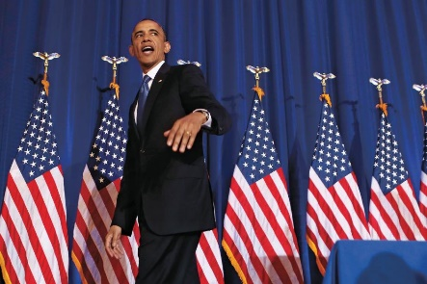
Haines brought home Obama’s effort to impose new rules and standards for targeted killings. Larry Downing/Reuters
The full parameters of her new position are not entirely clear. At the very least, Haines will be expected to exercise all of the powers of the director when he is absent. That means overseeing the Directorate of Intelligence, which analyzes intel and produces finished reports for policymakers, as well as the National Clandestine Service—the spies who steal secrets, run covert operations, and (at least for the time being) carry out drone strikes.
“Moving from a legal position to an operational role can be a challenging transition,” says Matthew Olsen, director of the National Counterterrorism Center and a former top Justice Department official. “But Avril has both the intellectual firepower and the collegial approach to succeed in her new position.”
Historically, the deputy job often varies based on whoever is CIA director. And one thing that is known is that John Brennan’s trust in Haines is implicit. Brennan, who has an affinity for lawyers and their logical way of thinking, turned to Haines for virtually every major decision when he was the counterterrorism chief in the White House. The two developed a strong professional chemistry, working endless hours together on the new targeted-killing policy.
Her principal nemesis is likely to be a chain-smoking, abrasive terrorist killer known only as ‘Roger.’
At the CIA, that policy—which calls for an end to the CIA’s drone program—will undoubtedly constitute Haines’s biggest challenge. She will be assuming power at the CIA as a principal author of a policy intended to dismantle the agency’s most prized counterterrorism program. In implementing this policy, she will be up against seasoned bureaucrats—spies who have spent their careers learning how to run covert operations against policies and campaigns to discredit leaders. “It’s these guys’ stock and trade,” says one senior intelligence official. “And they do it internally.”
Even her biggest supporters say that Haines will have to find her leadership voice as she takes on the CIA’s deeply entrenched culture. “Avril is so modest she doesn’t quite understand her power and how well people think of her,” says one senior administration official. “She needs to understand that it’s OK to walk into a room and expect people to pay attention.”

The CIA says Haines will not be viewed as a complete outsider at the agency. “She already is known to many here as someone who has gone to great lengths to help the CIA achieve its objectives,” says CIA spokesman Dean Boyd. “For those who don’t know her, we’re confident that she will be received extremely well, given her humility, intellect, integrity, and judgment.”
Nevertheless, she’s bound to face adversaries. Her principal nemesis is likely to be a chain-smoking, abrasive terrorist killer known only as “Roger,” the first name of his cover identity. Roger, chief of the CIA’s counterterrorism center, has presided over the drone program for years and is said to be a ferocious infighter who jealously guards his fiefdom. Intelligence officials say he is nothing short of contemptuous of lawyers and White House officials whose risk-averse ways, as he sees it, will make it harder to do his job: killing bad guys. And Roger is a survivor. One of the longest continually serving counterterrorism officials in the government, he has headed the CTC since 2006.
Roger, and others of his ilk, will sorely test the proposition held by Haines’s supporters that through hard work and decency she can win over even the greatest skeptics. But unbeknownst to so many of her colleagues, she has something besides mere work ethic and a nice demeanor going for her: the lawyer whom Rhodes calls “an international woman of mystery” has a life story that arguably has prepared her for anything.

