NSF URLs for Lynn Conway’s 2015 Pride Talk

NSF LGBT Pride Page
http://www.nsf.gov/od/odi/sep/lgbt.jsp

NSF 2015 LGBT Pride Program Brochure
http://ai.eecs.umich.edu/people/conway/Memoirs/Talks/NSF/Images/NSF_2015_Pride_Program.jpg

Powerpoint Slides for Lynn Conway’s NSF LGBT Pride Talk
http://www.nsf.gov/od/odi/presentations/2015_NSF_Pride_Talk_by_Lynn_Conway.ppsx

Video/Audio of Lynn Conway’s NSF LGBT Pride Talk
http://bcove.me/bkx8nwg8

Transcription of talk-captions with timeline
http://www.nsf.gov/od/odi/presentations/LGBT%20Pride%20Event-MP4%20(Transcript)%20file.txt

Screen snips for web-posting of links:
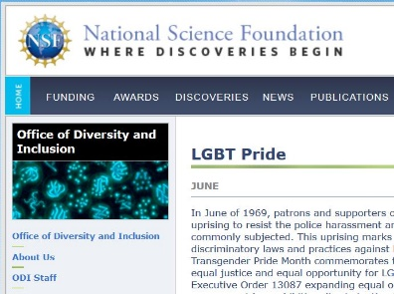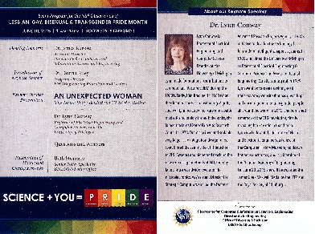

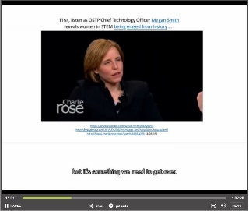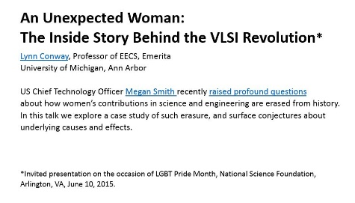

To download videos from Bcove, try using:
http://www.apowersoft.com/store/order-video-download-capture.html

Video Timeline:
00:10 Opening remarks by Dr. James Kurose, Assistant Director, Computer Science and Engineering Directorate (CISE)
03:38 Introduction of Keynote Speaker by Dr. Donna Riley, Program Director, ENG/Engineering Education and Centers
07:30 Keynote Speech by Prof. Lynn Conway
44:00 Question/Answer Session
54:20 Prof. Conway presents several follow-up “thought experiments”
58:50 Presentation of Plaque and Closing Remarks by Beth Strausser, Senior Policy Specialist, BFA/DIAS Policy Office

