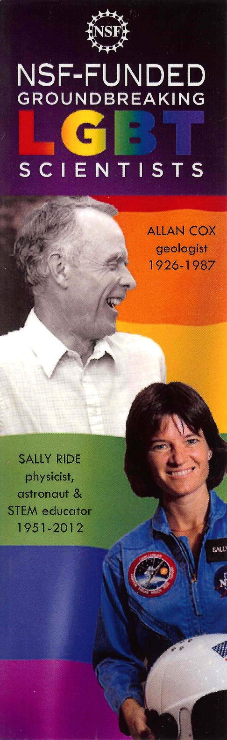
National Science Foundation LGBT Scientists Bookmark
[Print two-sided, then cut-out three bookmarks]

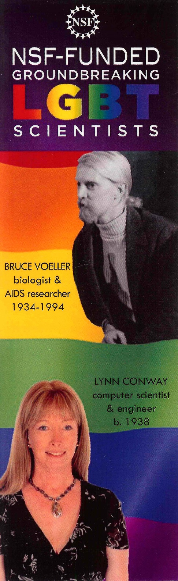
National Science Foundation LGBT Scientists Bookmark
[Print two-sided, then cut-out three bookmarks]

