A Conversation with Lynn Conway
Part of the IBM Research Distinguished Speaker Series
ON24 Presenter Essential Information

We will be making use of the ON24 Webinar Platform for your seminar. The guidelines below will help you to prepare your presentation and your browser for the highest quality experience, and will ensure you are able to connect online as easily as possible.

Your live session:

June 23, 2021
11am-12:15pm Eastern Time
(join at 10:45am ET for audio/visual check prior to seminar starting at 11am ET)

Resources:

Full quick-start guide can be found here: https://on24-prod.mindtouch.us/Public/PMXD_Quick_Start_Guide_for_Presenters

Presenter URL Link you will use for the live session: https://wcc.on24.com/webcast/present?e=3177587&k=90631FCDA67AE1E3BD9416F5643CCB14

Best Practices – Very Important:

- All presenters should use a supported browser (Chrome, Firefox or Edge).
- All presenters should try to use a wired Ethernet internet connection. If that is not possible and WiFi is the only option, please make sure you have a very strong WiFi signal.
- All presenters should use a headset/microphone, earbuds, earpods, or a quality external microphone, as their microphone and audio source. Use of typical in-laptop speakers and laptop microphone is not desirable and can produce an echo in the webcast audio.
- Please be sure to join at least 15 minutes before the live session opens to test your video and audio - these are the most common issues we see with presenters. Also please join the live session from the same location and network that you used for the pre-event prep call.
- Close all unused applications, especially those that may have access to your webcam (Skype, Microsoft Teams, etc.), or those which may be running bandwidth-intensive backups in the background (local drives backing up to network attached storage, Time Machine, cloud backup, etc.). Close extra browser tabs to conserve bandwidth.
- Please try to connect WITHOUT going through a VPN. If technical issues persists after troubleshooting, it is usually related to network configurations such as VPN or Firewalls. If this doesn't resolve the issue, please submit a case to Platform Support so our team can work with your internal IT department to find a resolution.
- Please have a print out of your presentation deck available.
- Please prepare to turn off all cell phones, mobile devices, PDAs, etc.

Logging into the ON24 platform:

After following the appropriate Presenter URL Link above, you will see the screen below, for both the prep/training session and the live session. After filling in your name and email, please log in using only the PRESENTER button. Do not use the PRODUCER or Q&A buttons.

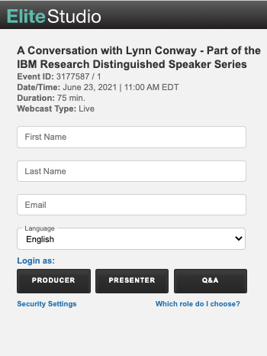

You will see a small screen which looks like the below when you first log in.

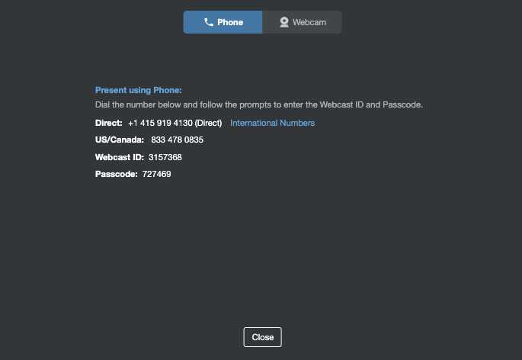

Do not dial in by “Phone”

Select "Webcam" at the top, and allow ON24 to access your default microphone and webcam, if your computer prompts. Then close the small window when your webcam shows as "connected".

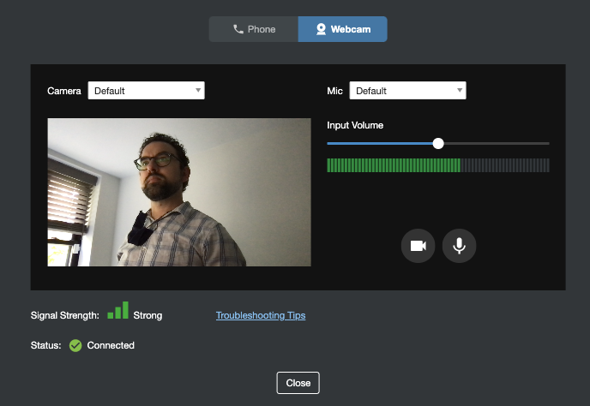

Once you are connected the PRESENTER view will look very similar to this when you log in, only with your slides pre-loaded.

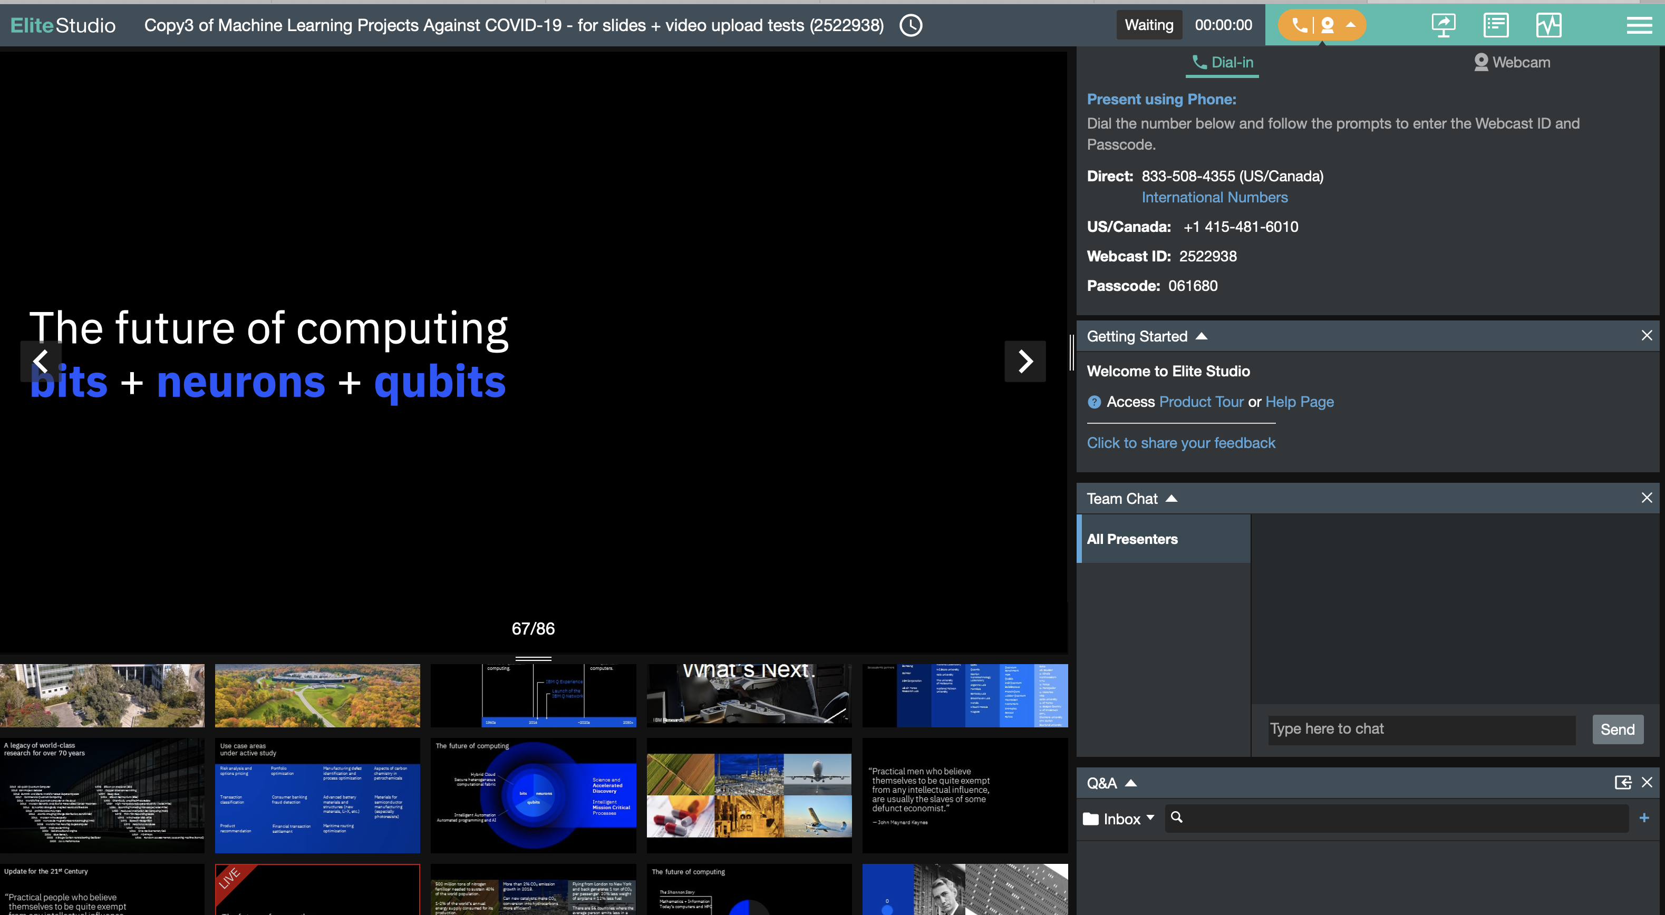

Do’s and Don’ts for Presenters:

- Do not dial in by phone. You must join through the “webcam” option, which will use your computer’s audio and/or attached headset/microphone peripherals.
- If you happen to close the small window which comes up when you first log in, before selecting to connect by webcam, you can bring it back by pressing the orange button near the top right corner of the screen.
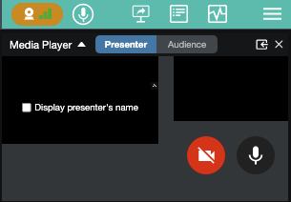

- Do not press any of the white icons in the teal-colored panel at the top right of the screen. These run demo content for the audience.


- You can close or minimize any of the panels on the right side of the screen except Team Chat for ease of use. (e.g. close Getting Started, Q&A, Attendees List, Presenters, Media Player). Close these panels by using the “X” in the upper right of each panel.
- You may also want to minimize the Q&A panel so that questions coming in from the audience are not distracting during your presentation. You do not need to do anything with the Q&A. Our Q&A moderator will read audience questions to you during the Q&A period.
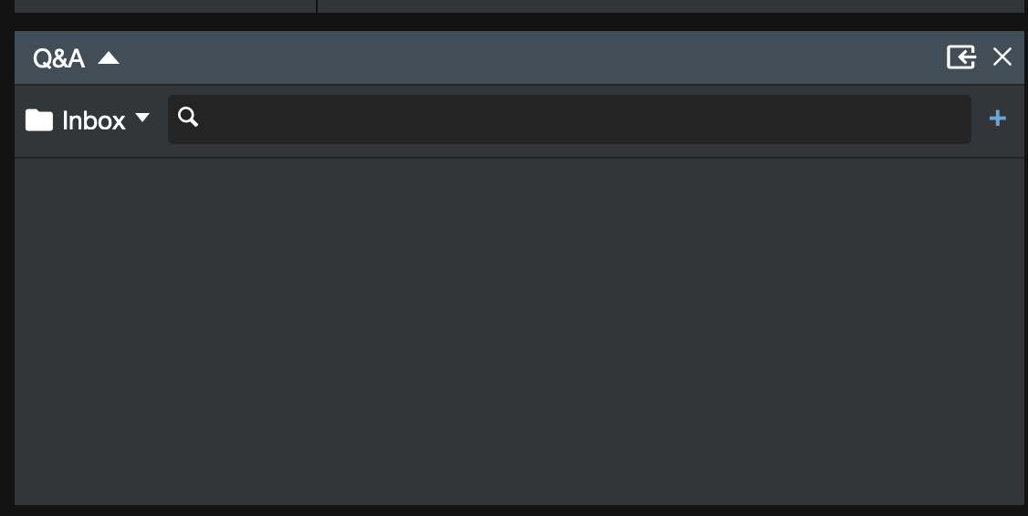

- The Media Player panel in the top right of your screen is where you can view the webcam feeds.
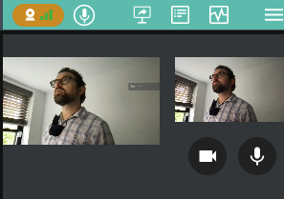

- Use the left and right arrows appearing at the edges of the live view window to advance your slides or go back.

- You may also skip to a particular slide by clicking on it in the slide browser panel at the bottom of the screen, and then clicking on the green “Push To Audience” button which appears.
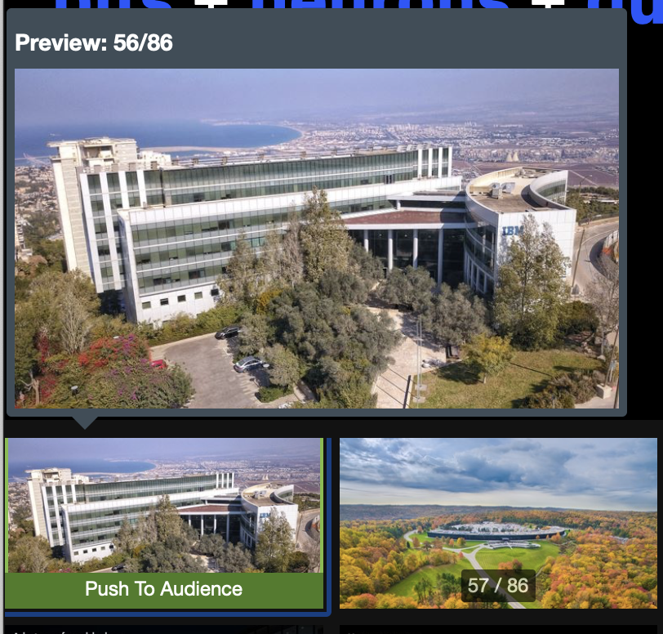

- Attendees will be allowed to enter the audience console 15 minutes before the scheduled start of the webinar. Presenters should avoid advancing slides during this time, as the audience will see the slides advancing. The presentation deck will contain an opening title slide which will be shown during this time.

- If you experience any technical difficulties during the live session, do not restart your browser. First send a message to All Presenters in the Team Chat panel and our live stream monitor will assist you.
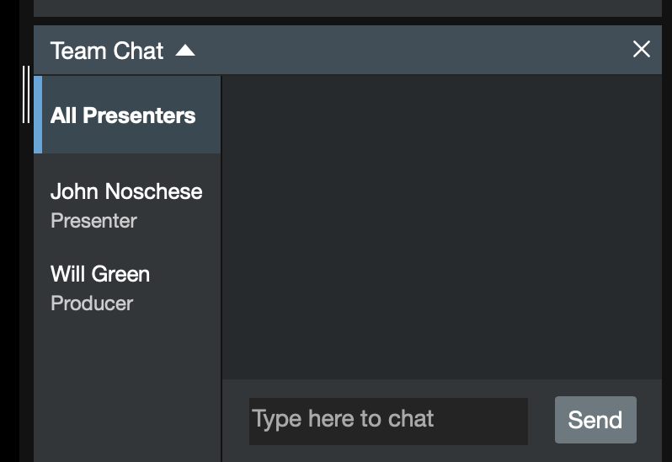

System Requirements for ON24 platform:

It's important that the presenters’ computers meet the minimum system requirements.
- Operating System:
  - Windows OS: 10 running the latest versions of Chrome, Firefox, or Edge - Chrome is preferred.
  - Mac OS: 10.10+ running or the latest version of Firefox or Chrome - Chrome is preferred.
- Browser Configuration: The browser must accept cookies and have JavaScript enabled.
- Screen Resolution: 1024x768 or higher
- Connection: Wired connection preferred (Wi-Fi is a secondary choice, as Wi-Fi is prone to connectivity drops)
- Connection Speed: 1 Mbps or faster (upload and download speed)

Using Team Chat:

The Team Chat window allows you to chat with presenters and other team members. You can send messages to all presenters at once or chat privately with specific individuals.

Troubleshooting Tips:

- Refresh Presentation Manager XD (F5) or try another browser.
- Clear cache/cookies to optimize browser performance.
- Reboot the computer if time permits.

