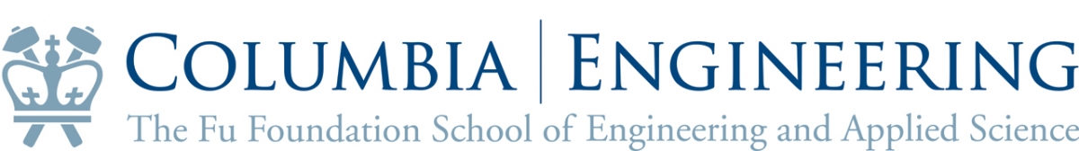

The Magill Lecture:
The Magill Lecture in Science, Technology and the Arts explores the exciting confluence of art and science and is made possible through the generosity of Dr. Frank N. Magill. The lecture has previously taken place annually during Dean’s Day & Reunion programming. The next Magill lecture will take place March 23, 2016 and will be geared towards a SEAS student audience.

Frank Magill:
Dr. Magill received his Master of Science degree in Civil Engineering from the School in 1934. In 1949, he founded the Salem Press, a California-based publisher of reference books in both the humanities and the sciences. Dr. Magill strongly believed that students of engineering and science should be exposed to the world of art and the humanities. He established this series to be an ongoing exploration of the synergy between art and science and a celebration of the pioneers who bridge the gap between artistic and scientific endeavors.

Past speakers:
Jim Albaugh 2002
Santiago Calatrava 2003
Charles Hoberman 2005
David Freedberg 2006
Ned Kahn 2007
Andy Setos 2008
Bob Bakish 2009
Theodore Zoli 2010 no video; I + T + QA = 1:30:00
Steve Perlman 2011 6:20I + 56:00T + 20:16QA = 1:23:36
Jeffrey Brock 2012 no video
Mark Hansen 2013 2:40I + 46:40T + 13:51QA = 1:03:11
Charles Hoberman 2014 no video

