Diversity in STEM Luncheon
Columbia University, Low Library, Trustee Room
12-1:30pm, March 23, 2016

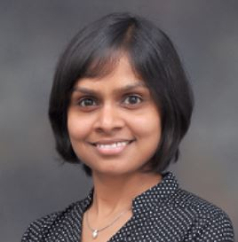  Shipra Agrawal  Asst Prof IOER | 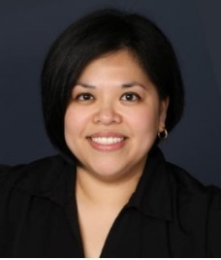  Melinda Aquino  Assc Dn MC Affairs | 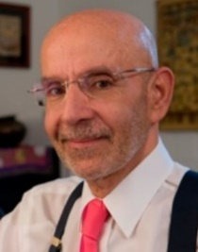  Peter Awn  Dn GS Prof Relig | 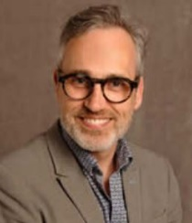  Walter Bockting  Prof MedPsych | 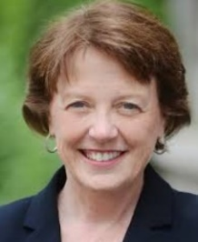  Mary Boyce  Dean of SEAS
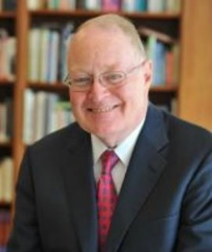  John Coatsworth  Prov Prof Hist,PA | 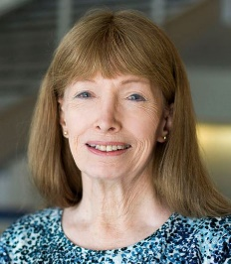  Lynn Conway  Pr Em EECS UM | 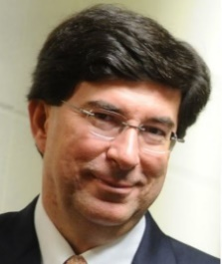  George Deodatis  Prof, Chair CEEM | 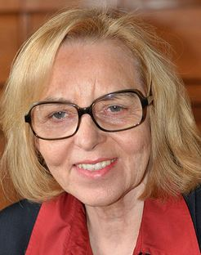  Anke Ehrhardt  Prof MedPsych | 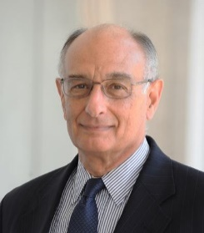  Don Goldfarb  Prof IOER
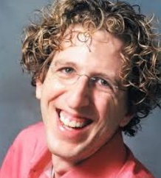  Eitan Grinspun  Assoc Pr CS | 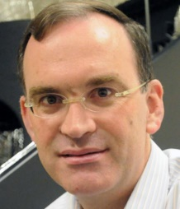  Jeffrey W. Kysar  Prof Ch ME | 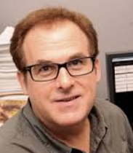  Andrew F. Laine  Prof Ch BioMedEng | 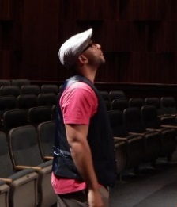  Lamar Lovelace  Dir Pub Prog Ev | 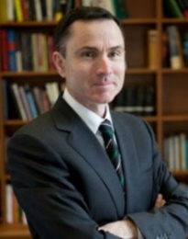  David Madigan  Dn ArSci Pr Stat
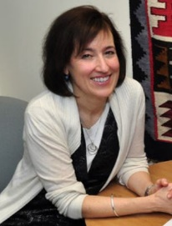  Claude Mellins  Prof Psychology | 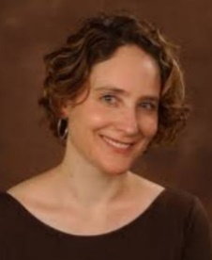  Amber Miller  Dn Sci Prof Physics | 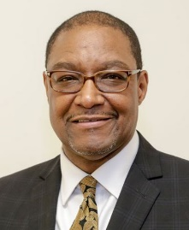  Dennis A. Mitchell  VPV FDI, Pr Dent | 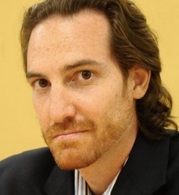  Barclay Morrison  Assoc Pr BioMed | 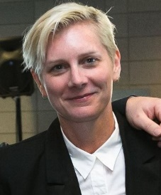  Star Sawyer  Ex Dir Alum Rel
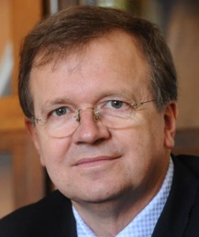  Peter Schlosser  Ch Prof EEE | 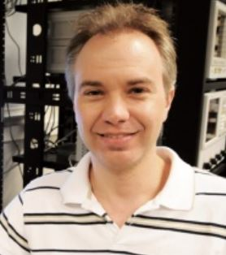  Ken Shepard  Prof of CS

