In 1968, IBM fired Lynn Conway for being transgender.

She finally got an apology.

‘I am the messenger for a lot of other people who have had exactly this experience’

Sydney Page, November 30, 2020.
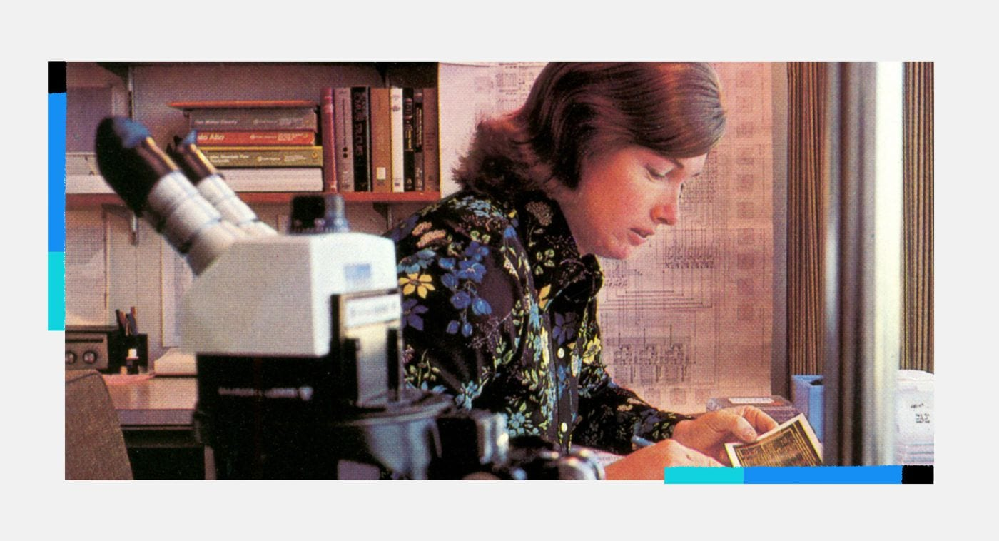
Lynn Conway in her office at Xerox PARC in 1977. (Lynn Conway)
When Lynn Conway started her career as a computer scientist at IBM in 1964, she quickly became known within the company for her raw talent, working on a team to produce technologies that would shape how advanced computers operate.
But Conway was riddled with anxiety and depression as she tried to shield her transgender identity while living as a man. At the time, she was 30 years old and married with two children.
Four years later, Conway decided to begin her medical gender affirmation journey.
When IBM’s corporate management team heard of Conway’s intentions, the chief executive at the time, Thomas J. Watson Jr., quietly fired her.
Conway, now 82, says she was crushed but that she ultimately understood.
“You can’t change what happened, and in fact, if you look at what happened from all perspectives, it pretty much was the only thing that could have happened,” said Conway. “When you connect the dots, you see it as a sign of the times.”
Fifty-two years later, IBM has formally apologized to Conway.
“IBM is a very different company than it was back then,” said Conway from her home in Michigan, where she lives with her husband, Charles Rogers, who is also a professional engineer.
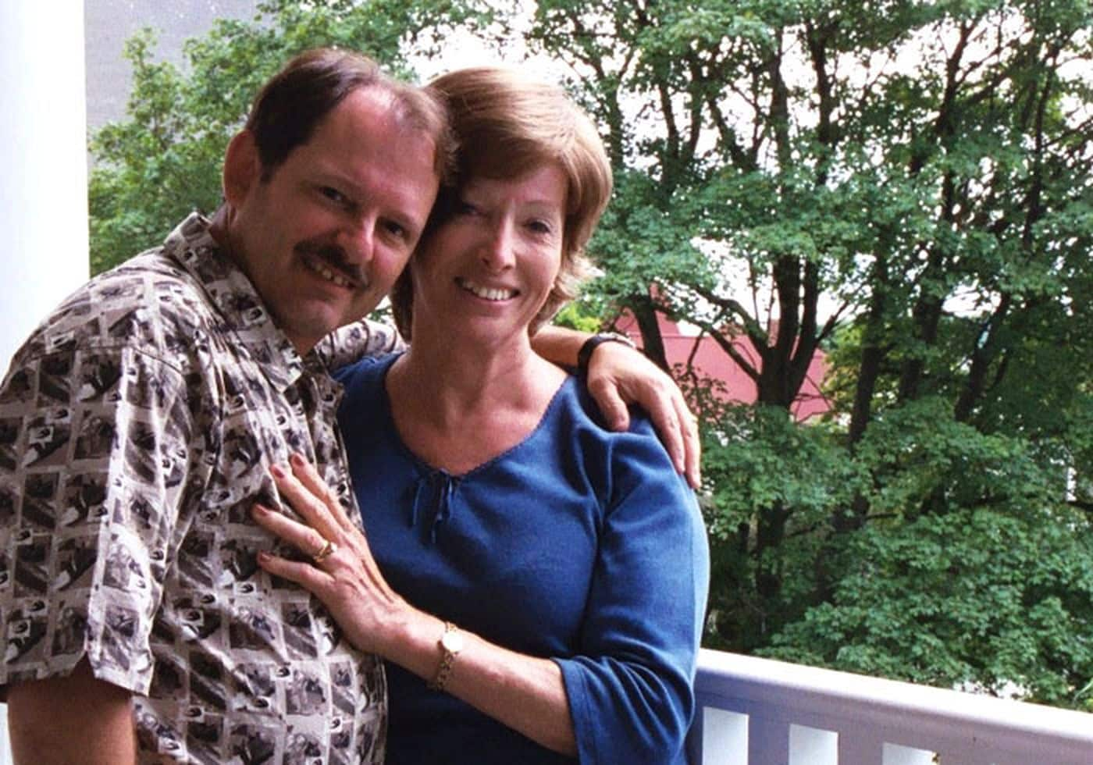
Lynn and her husband Charles Rogers on their Mackinac Island honeymoon in August 2002 (Charles Rogers).
Last month, the company invited Conway to attend a virtual meeting with its employees.
“I wanted to say to you here today, Lynn, for that experience in our company 52 years ago and all the hardships that followed, I am truly sorry,” said Diane Gherson, IBM’s senior vice president of human resources, at the event.
“We’re here today not only to celebrate you as a world-renowned innovator and IBM alum, but also to learn from you; and by doing so, create a more inclusive workplace and society,” she continued.
Conway says the apology and decades-delayed acknowledgment of her work was freeing, and that it provided her with a long-sought sense of closure.
For the company’s employees, the apology and subsequent discussion resonated deeply.
“The IBM trans community looks up to Lynn and are familiar with her story, so this moment was truly healing. They were able to express their admiration and thanks to Lynn and even though there were many people in the session, it really felt like an intimate, heartfelt moment,” said Ella Slade, the global LGBT+ leader at IBM.
IBM’s firing of Conway 52 years ago would be illegal today. In June, the Supreme Court ruled that gay and transgender workers are protected under federal laws prohibiting workplace discrimination.
“The U.S. Supreme Court decision has really opened up the world to transgender individuals who ordinarily would not have had their civil rights,” said Barbara Lee, a professor of human resource management at Rutgers University. “It was a tremendous step forward. It’s been a long time coming.”
Following the apology, Conway was presented with the IBM Lifetime Achievement Award — rarely bestowed upon employees or alumni — for exceptional technical innovations and visionary leadership.
“Lynn’s extraordinary technical achievements helped define the modern computing industry,” said Dario Gil, director of IBM research, of the award. “She paved the way for how we design and make computing chips today — and forever changed microelectronics, devices and people’s lives.”
After leaving IBM in 1968 and completing her gender affirmation, Conway reentered the computer science industry. The tech world, she quickly learned, was vastly different for her now.
“There were a lot of problems reentering Silicon Valley as a woman,” she said. “You are totally invisible.”
She worked her way from a contract programmer to a computer architect at Memorex Corp. She was then recruited by Xerox Palo Alto Research Center in 1973. All the while, she kept her transgender identity a secret.
At PARC, she spearheaded a group that worked to remodel computer chip design, giving rise to novel technologies which became known as the “Mead & Conway Revolution.”
Mead-Conway textbook cover, 1980.
Then Conway went on to join the U.S. Department of Defense, where she worked in strategic computing initiatives.
She gradually shifted her focus to academia, first as a visiting professor at the Massachusetts Institute of Technology and later, in 1985, as a professor of electrical engineering and computer science at the University of Michigan, where she taught until 1998.
Conway has been with her husband since 1987, and the two married in 2002. In their free time, the couple enjoys adventure sports.
“That’s how I learned to control fear — it isn’t by being daring, it’s the inverse,” she said. “It’s by putting yourself into situations where you keep learning how to make moves.”
When she retired, Conway learned that her transgender identity might be revealed by computer historians investigating her early work at IBM. Conway knew she would likely be outed eventually, so she created a website in 2000 to share her story and to connect with the transgender community.
“That was enormously liberating,” said Conway, who rapidly emerged as a prominent transgender activist. “It really gave me the feeling of being alive.”
“I could feel a certain coolness from people, but again, I’m not going to judge because I expected that,” Conway said. “But it was compensated for tremendously by being able to meet and interact with younger trans people in their 20s and 30s all over the world.”
Even after coming out and publicly disclosing why IBM fired her, the company stayed silent on the matter for two decades.
“For all these years, I wondered why IBM hadn’t apologized,” said Conway.
Her website quickly became a resource for trans people, said Rochelle Diamond, a research scientist at the California Institute of Technology and the retired chairwoman of the National Organization of Gay and Lesbian Scientists and Technical Professionals.
“We are very proud of Lynn for fighting the good fight,” said Diamond. “In 1981, I was forced out of the closet and lost my job, so I was able to really relate and talk with her about her journey.”
Although she has become widely recognized, she knows her story is not unique.
“This isn’t about me,” Conway said. “I am the messenger for a lot of other people who have had exactly this experience, or big pieces of it. We are all just reaching out and trying to connect.”

