IBM fired U-M professor Lynn Conway for coming out as trans in 1968. 52 years later, the company apologized
Roni Kane, For The Daily
Sunday, November 29, 2020 - 1:43pm
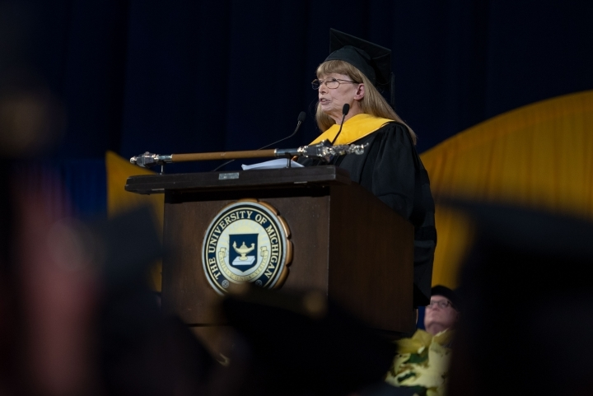
Professor Lynn Conway speaks at the 2018 Winter Commencement in Ann Arbor. Alec Cohen/Daily

At the University of Michigan’s 2018 Winter Commencement, Lynn Conway, professor emerita of electrical engineering and computer science, encouraged the graduating class to embrace changes and transitions as an inevitable part of their future adventures.
“You’re embarking in an era of accelerating social change,” Conway said. “You’ll encounter increasingly diverse, often conflicting ways of thinking.”
She then stepped away from the stage to give the class of 2018 their moment to shine. But on Oct. 14, 2020, Conway was the one in the spotlight.
At a public event celebrating LGBTQ+ inclusion, the International Business Machines Corporation presented Conway with a rare lifetime achievement award. The award accompanied IBM’s apology to Conway, which came 52 years after the company fired her for coming out as transgender.
The apology epitomized what Conway had preached in her commencement address: positive change occurs when people come together to build a future that transcends the shortcomings of the past.
Though not a household name like Thomas Edison, Nikola Tesla or Alan Turing, Conway appears alongside them in Electronic Design’s “Hall of Fame” for revolutionizing the microchip, which powers technologies from smartphones to spacecrafts. In 1964, Conway began researching supercomputers at IBM as a man.
Four years later, Conway decided to transition and receive gender-affirmation medical care. When she came out, IBM, then led by Chief Executive Officer T.J. Watson Jr., fired her.
In her memoir, “IBM-ACS: Reminiscences and Lessons Learned From a 1960’s Supercomputer Project,” Conway reflected on the logic behind IBM’s decision. She wrote that IBM executives were concerned that her gender transition would affect the mental health of her co-workers, since stigma surrounding transgender people was so pervasive at that time.
“I learned later … that the executives feared scandalous publicity if my story ever got out,” Conway wrote.
In an email to The Michigan Daily, an IBM spokesperson wrote that IBM established history’s first corporate “equal opportunity policy” in 1953, which prohibited discrimination on the basis of “race, color and creed.” However, the spokesperson wrote that the company did not specifically protect non-cisgender individuals, like Conway, until 2002.
Conway told The Daily “she lived her life in stealth” after IBM. She resumed her research career at other technological companies under her new identity as a woman until she “quietly came out” as transgender by creating a website while working as a professor at the University in 1999.
Conway could have ended her connection to IBM entirely. However, she said she felt compelled to contact them again around 1999 and gain permission to self-publish the research she had done while employed by the company.
“I realized I had to come out more widely,” Conway said. “I was worried about my deadname being on their papers.”
Conway said IBM allowed her to post the documents on her website, but they did not formally express any regrets for firing her at the time.
Meanwhile, Conway’s website was gaining worldwide attention, and not only from fellow engineers. Other transgender individuals also began to regard her as a mentor.
“More and more trans people around the world were learning about my story because my web pages back then were one of the few blog sites that trans people around the world went to,” Conway said. “My page was translated by volunteer translators into many languages … it was part of the Trans Revolution.”
Tara Maclachlan, the vice president of industrial internet of things strategy at Inmarsat, a technology company in the United Kingdom, has been virtually following Conway’s story since 2000. Maclachlan, like Conway, is a trans woman working in a STEM field, and she has also previously worked with IBM.
Maclachlan told The Daily she feels a deep connection to Conway because of their similarities. She said Conway’s story has inspired her to proudly publicize her own gender identity and to pursue happiness in her work and personal life.
“I think Lynn is one of my true role models,” Maclachlan said. “I don’t use that word lightly. I think the fact that she stood up for what she believed in before it was even close to being commonplace is such an inspiration.”
Maclachlan also had the chance to hear Conway speak at a technology conference in Washington D.C., a couple years ago. Maclachlan said it was empowering to see an openly transgender woman acknowledged for her work at a large-scale conference.
Besides re-asserting her place in the technological industry after years of invisibility, Conway has also shared her story with students at the University.
Charles Cohen, the current chief technology officer of the Cybernet Systems Corporation in Ann Arbor, received his Ph.D. from the University in 1996. Conway was his dissertation adviser.
Cohen said working with Conway was a life-changing experience. Academically, he said Conway challenged him as a writer and a thinker, but she remains his mentor in everything from work to dirt biking.
“She dirt bikes — I bet you didn’t know that about her,” Cohen said before laughing. “She always lives on the edge of everything she does. She takes very calculated risks, but she certainly takes risks. If there’s no chance of failure, it’s boring.”
University students are still discovering Conway’s story today. LSA junior Noah Streng said he became fascinated with her story when Forbes first reported IBM’s apology.
“As a member of the LGBTQ+ community, it is incredibly inspiring to see people like Dr. Conway overcome so much adversity and be such a pioneer for social change, breaking barriers for LGBTQ+ people everywhere,” Streng said.
Throughout the next 20 years, more IBM employees became familiar with Conway’s story via her website and social media presence. In particular, Diane Gherson, a senior vice president at IBM, wrote in an email to The Daily that she first heard the story this past summer on Conway’s wiki page.
“I was stunned and heartbroken,” Gherson wrote.
Two decades after their last contact, IBM suddenly reached out to Conway again to invite her to headline a public company event on Oct. 14. At the virtual event, Conway was officially awarded the prestigious IBM Lifetime Achievement Award which signifies that she “changed the world through technological inventions.”
After celebrating her technological achievements, Gherson, who also hosted the event, personally apologized to Conway on behalf of the company half a century after she was fired.
“I wanted to say to you here today, Lynn, for that experience in our company 52 years ago and all the hardships that followed, I am truly sorry,” Gherson said at the event.
Gherson went on to describe the changes IBM has made to their policies for LGBTQ+ inclusion, which includes a firm-wide health care plan that helps cover gender-affirming related care.
“I’m confident in saying … you would have been treated quite differently today,” Gherson said to Conway. “But all that doesn’t help you, Lynn … So, we’re here today not only to celebrate you as a world-renowned innovator and IBM alum, but also to learn from you, and by doing so, create a more inclusive workplace and society.”
Lynn joked to The Daily that though she was a “good spy” — alluding to her long history of hiding her transgender identity — she could not contain the visible emotion that came to her face when she heard the apology.
“It was done in such an obviously heartfelt and authentic way that, at first, I was kind of speechless because I did not expect an apology,” Conway said.
Ella Slade, the global LGBT+ leader at IBM, attended the Oct. 14 event. In an email to The Daily, Slade wrote that Conway’s emotion was shared by the LGBT+ employees watching.
“The IBM trans community look up to Lynn and are familiar with her story, so this moment was truly healing,” Slade wrote. “Lynn made a comment at one point about her joining this IBM event was like returning home, and it’s hard not to get choked up hearing that.”

The apology may have come 52 years after the fact, but Conway told The Daily she feels this moment in time — and now her story — has become part of a revolution in social acceptance. For her, the apology has become a symbol of her and IBM recognizing their “joint humanity” and celebrating how far they both have come.
“The thing is, this story is not entirely about me, or even about IBM,” Conway said. “We’re the messengers. Our story is a lesson: you can never take for granted that you really know what you’re doing now and how it will affect the future. It’s a new kind of social awareness.”
Daily News Contributor Roni Kane can be reached at ronikane@umich.edu.

