DARPA 60th Links and Images for Homepage:

Link to MTO/ERI D60 Plenary Panel:
https://youtu.be/W_cB8VYunY8?list=PL6wMum5UsYvbLCUdhDjA_j0cXhlBI0jnW&t=3500 (VIDEO)
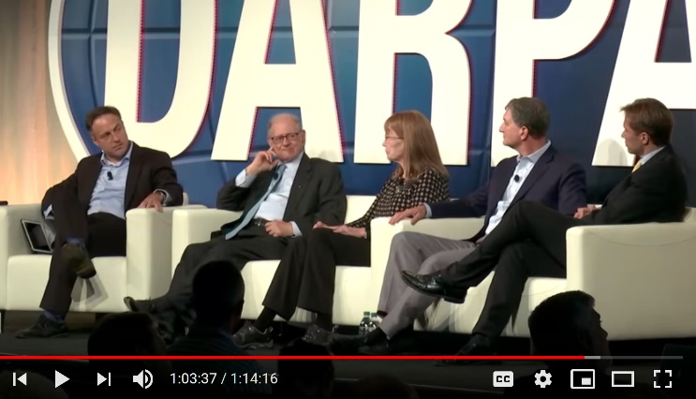

Link to Lynn’s D60 Plenary-Talk:
http://ai.eecs.umich.edu/people/conway/Memoirs/DARPA60/Lynn_Conway_D60_Plenary_Talk.pdf (PDF)
https://youtu.be/W_cB8VYunY8?list=PL6wMum5UsYvbLCUdhDjA_j0cXhlBI0jnW&t=1404 (VIDEO)
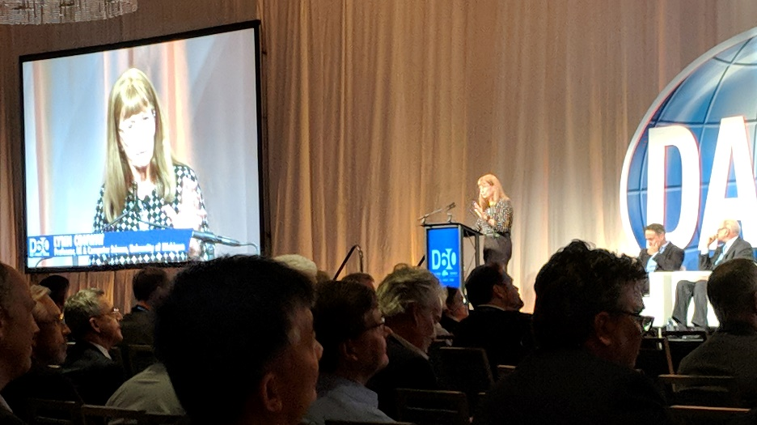

Lynn’s D60 Speaker Bio
https://d60.darpa.mil/speakers/MsLynnConway.html
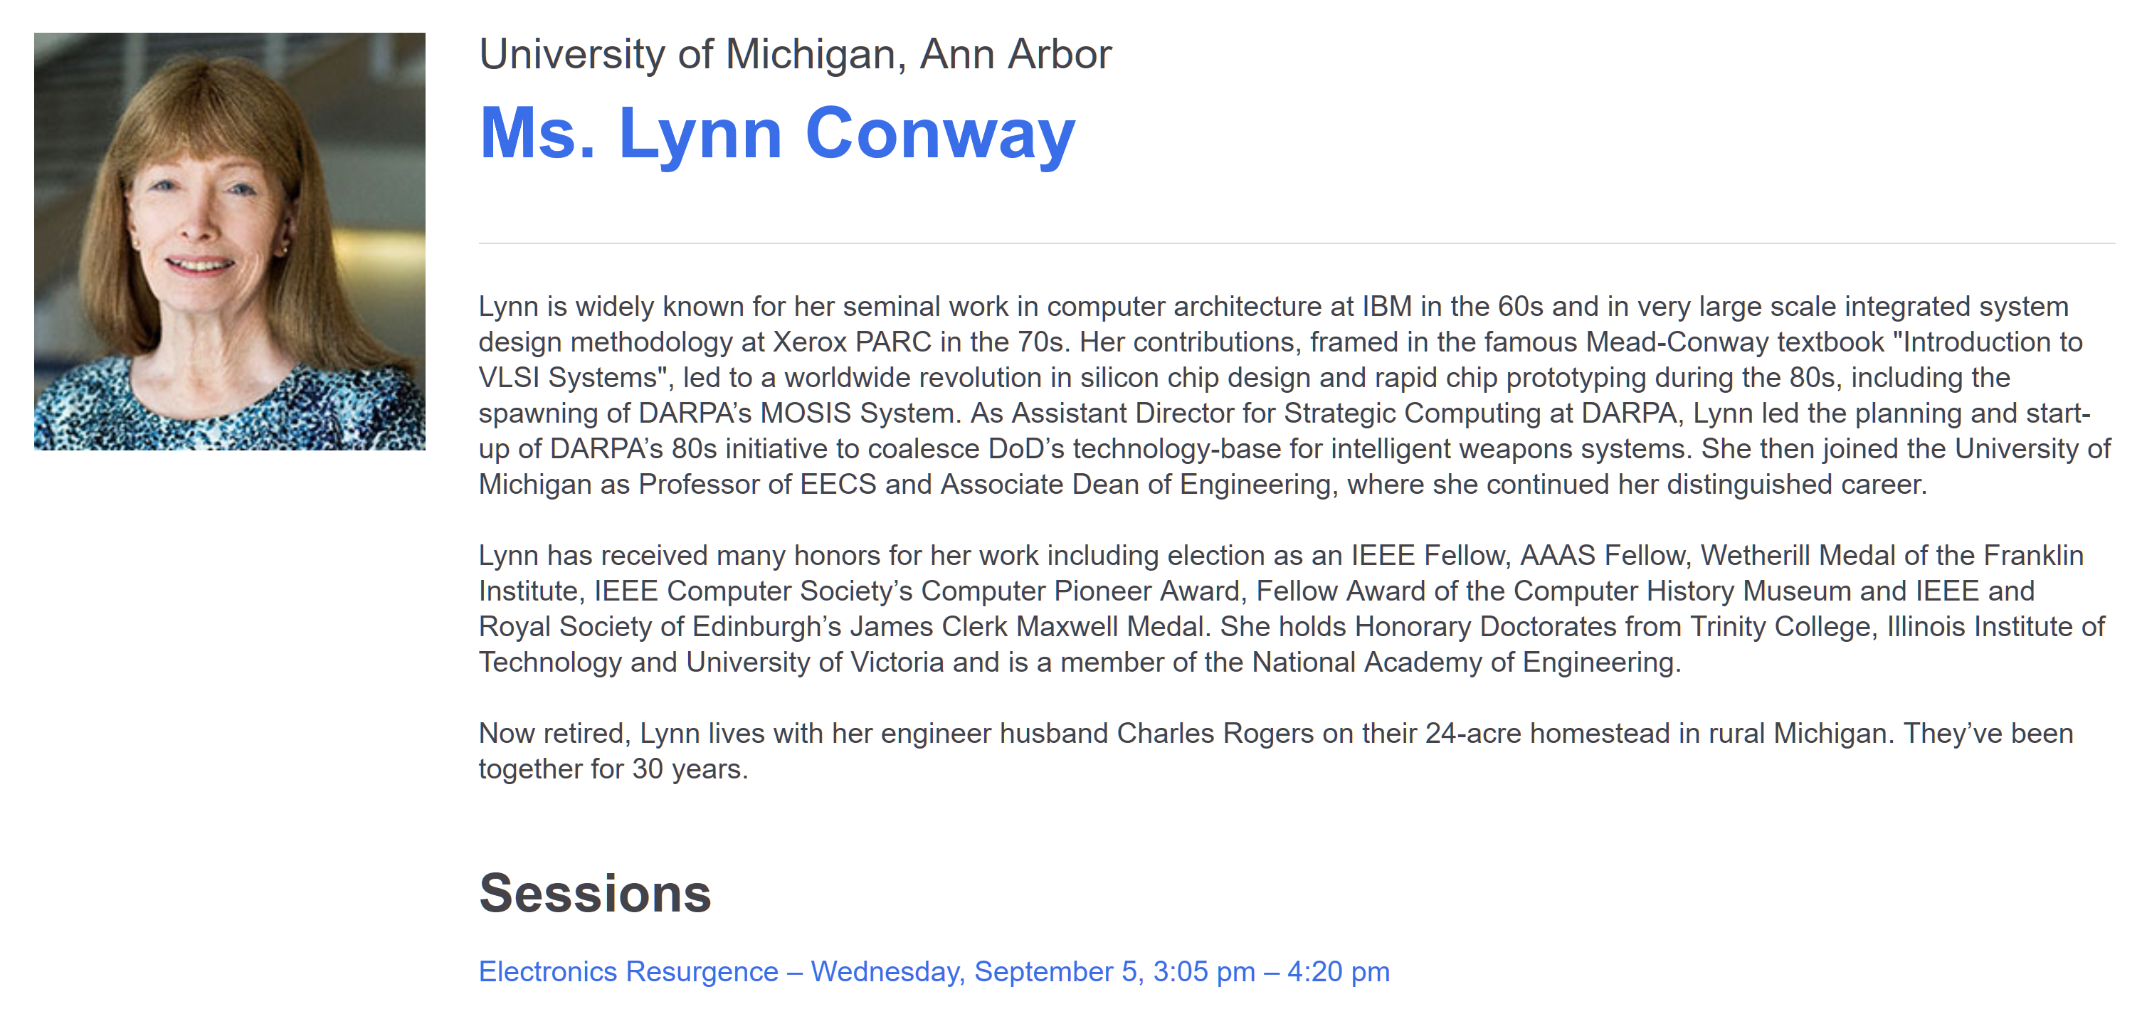

D60: DARPA’s 60th Anniversary Celebration
https://d60.darpa.mil/
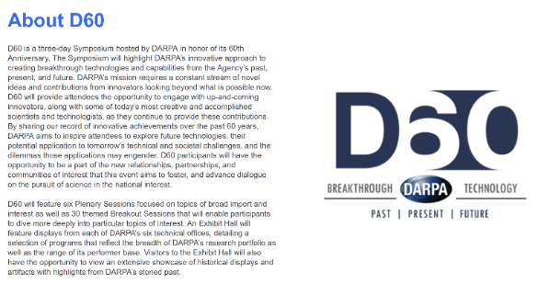

DARPA: 60 Years of Challenges and Breakthroughs (Video)
https://www.youtube.com/watch?v=Fs5JStyJlvc
