“Hi-tech researcher chips in to develop smart computer”,
By Michelle Osborn, USA Today, June 7, 1983, p. 3B
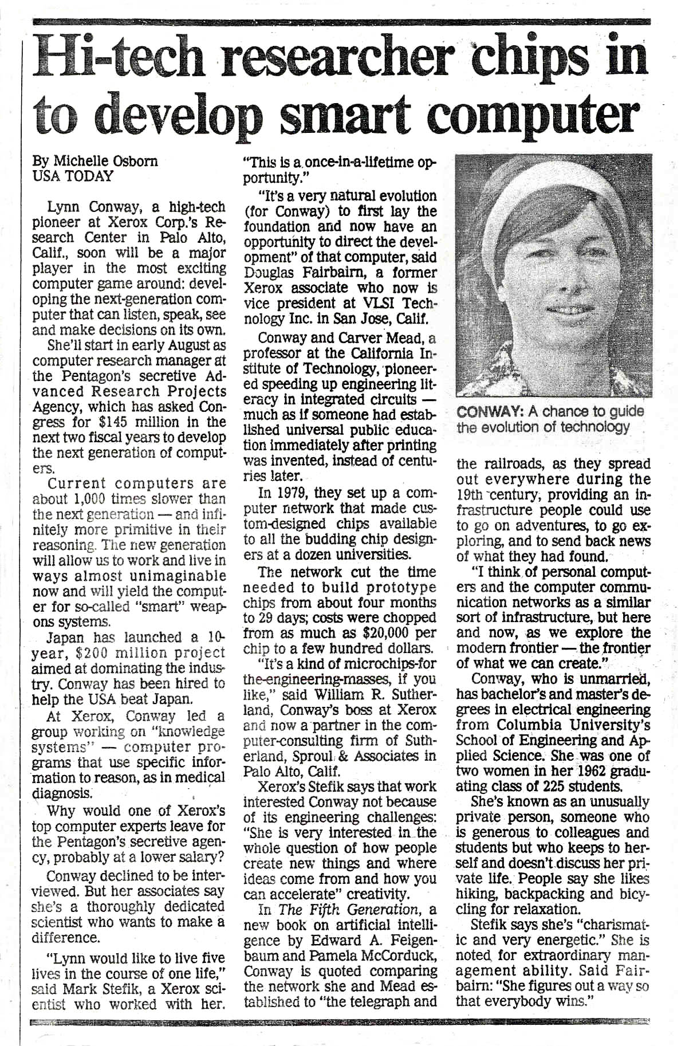
“Hi-tech researcher chips in to develop smart computer”,
By Michelle Osborn, USA Today, June 7, 1983, p. 3B

Lynn Conway, a high-tech pioneer at Xerox Corp.'s Research Center in Palo Alto, Calif., soon will be a major player in the most exciting computer game around: developing the next-generation computer that can listen, speak, see and make decisions on its own.
She'll start in early August as computer research manager at the Pentagon's secretive Advanced Research Projects Agency, which has asked Congress for $145 million in the next two fiscal years to develop the next generation of computers.
Current computers are about 1,000 times slower than the next generation — and infinitely more primitive in their reasoning. The new generation will allow us to work and live in ways almost unimaginable now and will yield the computer for so-called "smart" weapons systems.
Japan has launched a 10-year, $200 million project aimed at dominating the industry. Conway has been hired to help the USA beat Japan.
At Xerox, Conway led a group working on "knowledge systems" — computer programs that use specific information to reason, as in medical diagnosis.
Why would one of Xerox's top computer experts leave for the Pentagon's secretive agency, probably at a lower salary?
Conway declined to be interviewed. But her associates say she's a thoroughly dedicated scientist who wants to make a difference.
"Lynn would like to live five lives in the course of one life," said Mark Stefik, a Xerox scientist who worked with her.
"This is a once-in-a-lifetime opportunity."
"It's a very natural evolution (for Conway) to first lay the foundation and now have an opportunity to direct the development" of that computer, said Douglas Fairbairn, a former Xerox associate who now is vice president at VLSI Technology Inc. in San Jose, Calif.
Conway and Carver Mead, a professor at the California Institute of Technology, pioneered speeding up engineering literacy in integrated circuits much as if someone had established universal public education immediately after printing was invented, instead of centuries later.

In 1979, they set up a computer network that made custom-designed chips available to all the budding chip designers at a dozen universities.
The network cut the time needed to build prototype chips from about four months to 29 days; costs were chopped from as much as $20,000 per chip to a few hundred dollars.
"It's a kind of microchips-for the-engineering-masses, if you like," said William R. Sutherland, Conway's boss at Xerox and now a partner in the computer-consulting firm of Sutherland, Sproul, & Associates in Palo Alto, Calif.
Xerox's Stefik says that work interested Conway not because of its engineering challenges: "She is very interested in the whole question of how people create new things and where ideas come from and how you can accelerate" creativity.
In The Fifth Generation, a new book on artificial intelligence by Edward A. Feigenbaum and Pamela McCorduck, Conway is quoted comparing the network she and Mead established to "the telegraph and the railroads, as they spread out everywhere during the 19th century; providing an infrastructure people could use to go on adventures, to go exploring and to send back news of what they had found.
"I think of personal computers and the computer communication networks as a similar sort of infrastructure, but here and now, as we explore the modern frontier — the frontier of what we can create."
Conway, who is unmarried, has bachelor's and master's degrees in electrical engineering from Columbia University's School of Engineering and Ap- plied Science. She was one of two women in her 1962 graduating class of 225 students.
She's known as an unusually private person, someone who is generous to colleagues and students but who keeps to herself and doesn't discuss her private life. People say she likes hiking, backpacking and bicycling for relaxation.
Stefik says she's "charismatic and very energetic." She is noted, for extraordinary management ability. Said Fairbairn: "She figures out a way so that everybody wins."

