Computer History Museum 2014 Fellows Award:

“What Words Can We Leave to Guide Them?”
Acceptance talk by Lynn Conway, April 26, 2014

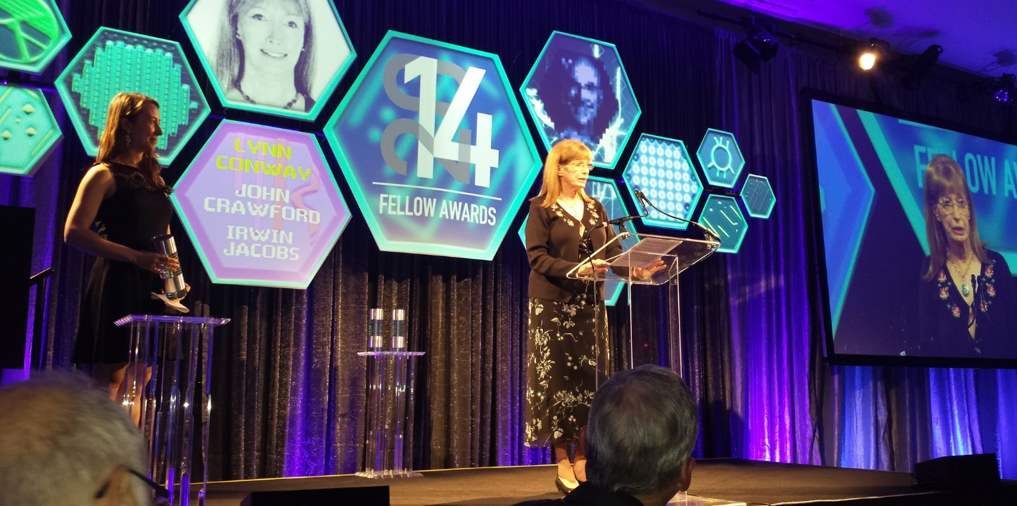

What a thrill it is to be here tonight in this very special place …where in the displays and archives we see so many tracks left behind by those who’ve gone before … and where we can ponder and wonder where it’s all headed next.
And that’s the greatness of our wonderful field of computing: it provides us with the intellectual-power-tools and social-interaction-tools to ever-further explore the greatest frontier of all: the frontier of what it’s possible to do.
I feel especially honored to be welcomed into the Hall of Fellows, for it’s a place where many of my personal heroes already reside.
And it’s also wonderful to meet and share war-stories with friends and colleagues here. As we age, even more than the tracks we’ve left behind, it’s our shared memories of the teams we joined and the adventures we went-on together, that count.
While flying out here this week, I recalled another flight, almost 50 years ago back in 1965. I was in my 20’s then and on the team that was architecting a secret new IBM supercomputer.
My suitcase held the lab-notes for the machine’s architectural simulator. And, as we flew along, I studied a spellbinding new book: Steve Roper’s “A Climber’s Guide to Yosemite Valley.”
Along with thousands of other young engineers streaming into Silicon Valley ... I was inexorably pulled along by a deep sense of serious adventures ahead …
When I found myself at Xerox PARC in 1973, I had no idea just how wild it was all going to become ... it was a magical place where folks were finding gold everywhere and rushing about sharing it with everyone else, collectively launching the modern personal-computer revolution.
Meanwhile, under the leadership of Bert Sutherland and Ivan Sutherland, some of us teamed-up, figured-things-out, and showed folks how to exploratorily-craft complex digital microelectronic machines and how to get them printed in silicon. What a time it was!
A number of folks here tonight participated in those adventures, and it’s wonderful to see you again. I’d particularly like to recognize some very special people at my table:
First, Bert Sutherland and his wife Sylvia ... One of the great research managers of the Valley, Bert took a big chance on me, and was my mentor and coach all along the way. I couldn’t have done all that stuff without his guidance.
Next, Dick Lyon and his wife Peggy Asprey ... Dick is one of the great engineering explorers ... back on our first ascents of big walls of microelectronics we’d often look up, look round at each other and wonder ... Oh geez, can anyone lead this next pitch? Dick would step up, take the lead, make the crux moves and bring us up. We’d never have made the tops without him.
And finally, my husband and soul-mate Charles Rogers, yet another engineer! …We been together for 26 years now, enjoying a succession of one exciting adventure after another!
Looking ahead, I’d like us to thoughtfully reflect on all the adventurous young people now streaming into Silicon-Valleys all around the world … hoping to join in, team-up and engineer ever-better futures.
What words can we leave to guide them, and their children and their children’s children – so that they too can go adventure-surfing together, high-atop the ever more wondrous incoming waves of innovation? ... What words? ... And then I remember the legendary French writer and aviator, Antoine de Saint-Exupéry, who left us these:
“If you want to build a ship, don’t drum up people to collect wood and don’t assign them tasks and work, but rather teach them to long for the endless immensity of the sea.”

