2014 Fellow Awards

http://www.computerhistory.org/fellowawards/current/
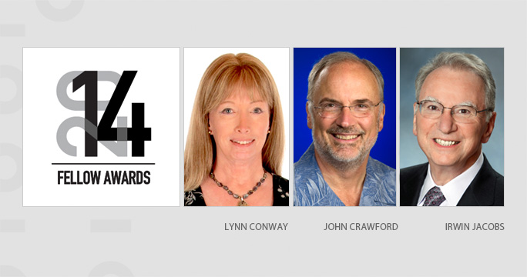

About the Fellow Awards
Since 1987, the Computer History Museum Fellow Awards have honored distinguished technology leaders who have forever changed the world with their accomplishments. This prestigious award recognizes each Fellow’s role in the advancement of computing history, as well as the impact of their contributions. The Fellows have truly bettered our lives and our society. The Computer History Museum is proud to have a part in highlighting and preserving the stories of these esteemed technology heroes for future generations.

The 2014 Fellow Award Honorees are:
- Lynn Conway, for her work in developing and disseminating new methods of integrated circuit design.
- John Crawford, for his seminal work on industry-standard microprocessor architectures.
- Irwin Jacobs, for his pioneering work in digital mobile telephony, data and communications technology.

WHEN: Saturday, April 26, 2014
6:00 pm Hosted Cocktail Reception
7:00 pm Fellow Awards Ceremony and Dinner
9:00 pm Cordials and Cigars, Coffee and Dessert; Wander the new Revolution Exhibition

VENUE: Computer History Museum, 1401 N Shoreline Blvd, Mountain View, California (Directions)

DRESS: Black tie optional

AUDIENCE: CEOs and high-level executives, venture capitalists, luminaries, pioneers, academicians, influential media, past Fellows and other esteemed supporters of computing history and the Museum.

Press Releases

The Computer History Museum Announces its 2014 Fellow Award Honorees
VLSI Design, Intel x86 Processor Architecture, Digital Communications Celebrated at Annual Awards Ceremony
—December 3, 2013—
The Computer History Museum (CHM), the world’s leading institution exploring the history of computing and its ongoing impact on society, today announced its 2014 Fellow Award honorees:
- Lynn Conway, for her work in developing and disseminating new methods of integrated circuit design through her work on the VLSI (Very Large Scale Integration) process,
- John Crawford, chief architect of the Intel x86 processor architecture, for his seminal work on industry-standard microprocessor architectures, and
- Irwin Jacobs, for his pioneering work in digital mobile telephony, data and communications technology.
The three Fellows will be inducted into the Museum’s Hall of Fellows on Saturday, April 26, 2014, at a formal ceremony where Silicon Valley executives, technology leaders, and Museum supporters will gather to celebrate the accomplishments of the Fellows and their impact on society.
The Computer History Museum Fellow Awards honor exceptional men and women whose ideas have changed the world. Their tool has been the computer, their accomplishments as wide-ranging as computing itself: networking, hardware, software, storage, programming languages—technologies that affect nearly every human alive today.
The Awards are part of the Museum's vision to explore the computing revolution and its impact on the human experience. The tradition began in 1987 with the first Fellow, early programming pioneer Grace Murray Hopper, and has grown to a distinguished group of 60 members.
Fellow nominations are open to the public and reflect a diverse range of viewpoints and areas of computing. Final selection is made by a panel of historians, researchers, industry leaders, Museum staff and other Museum Fellows
“Our Fellows represent the leading figures of the information age—men and women who have shaped the computing revolution and had a profound impact on society,” said John Hollar, Museum President and CEO. “We are delighted to welcome Lynn Conway, John Crawford and Irwin Jacobs, and we will be honored to celebrate their work and achievements through their induction into the Hall of Fellows next year.”
For more information on the Fellow Awards, please visit:
http://www.computerhistory.org/fellowawards/current/
About the Computer History Museum
The Computer History Museum in Mountain View, California is a nonprofit organization with a four-decade history as the world’s leading institution exploring the history of computing and its ongoing impact on society. The Museum is dedicated to the preservation and celebration of computer history and is home to the largest international collection of computing artifacts in the world, encompassing computer hardware, software, documentation, ephemera, photographs and moving images.
The Museum brings computer history to life through large-scale exhibits, an acclaimed speaker series, a dynamic website, docent-led tours and an award-winning education program. The Museum’s signature exhibition is “Revolution: The First 2000 Years of Computing,” described by USA Today as “the Valley’s answer to the Smithsonian.” Other current exhibits include “Charles Babbage's Difference Engine No. 2,” “Going Places: The History of Google Maps with Street View,” and “The PDP-1 and IBM 1401 Demo Labs.”
For more information and updates, call (650) 810-1059, visit www.computerhistory.org, check us out on Facebook, and follow @computerhistory on Twitter.

Press Contact:
Carina Sweet
csweet@computerhistory.org
(650) 810.1059

