Hi Dag,

Here are some further stills to mix into the CHM video. I suggest inserting ~ two images per HD video still, yielding landscape-format stills.

There are two sets:

(i) MIT ’78 (7 HD paired-stills)

(ii) MPC79 (5 HD paired-stills).

I’ve included thumbnails of the images in this document. The sequence of images (from top down to the bottom of each page) conveys in visuals some of the essence of each story.

To obtain online full-resolution JPGs, simply CTR+CLICK on the images (they contain embedded links to the JPGs, GIFs PDFs).

Most of the images are of quite high resolution. However, all are of vital-historical-significance, thus begging for their full inclusion, independent of image quality.

If you have any questions, send me a line!

Cheers!

Lynn

MIT ’78: Here are some really historic MIT ‘78 photos. CTR+CLICK images to retrieve originals. They are displayed in pairs (for side-by-side merging into HD stills), with the pairs sequenced to tell the story.
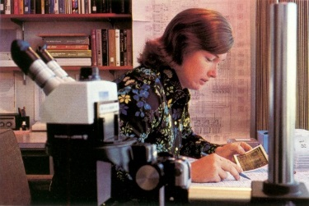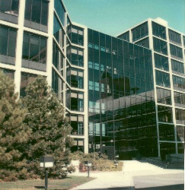
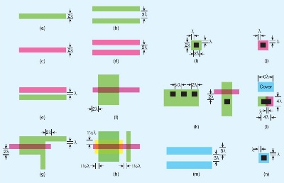
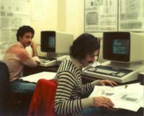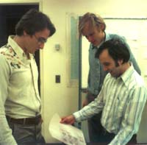
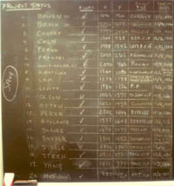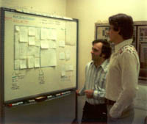
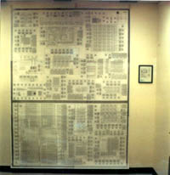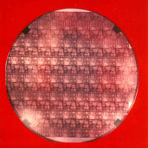
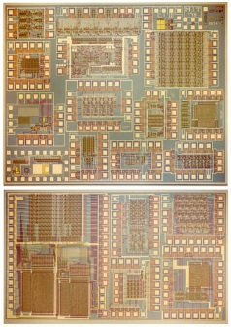
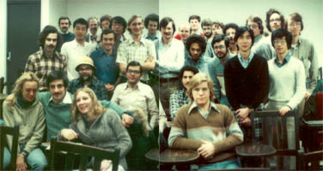

MPC79: Here are truly historic images re MPC ’79 and its aftermath (click to get originals; most are JPGs; a couple are covers of PDFs). These are paired for insertion in HD stills and sequenced to tell the story.
