Photos of Lynn Conway

From Lynn’s childhood:
These old photos, while of low resolution, are historically significant. Scanned from very old, very tiny prints in my baby-book, they’re only a couple of hundred pixels in each dimension.
One possibility for including them in the HD video would be to insert them as mosaics into two HD stills, with captions and some space around each of them – with extended run-time so folks can read them.

Age ~5 months: With my father and mother; My 3rd birthday.
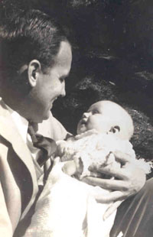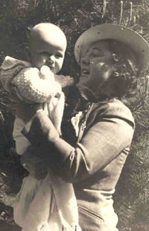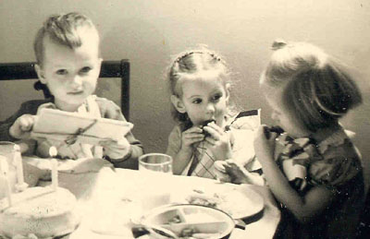

Almost age 3: Loved to be outside in the snow; Age 4: Reading to teddy bears; Age 4, daydreaming.
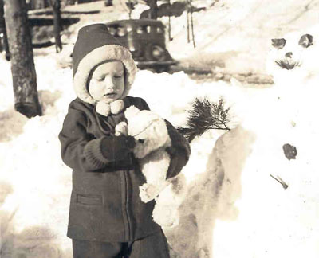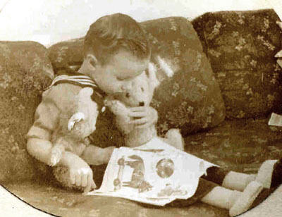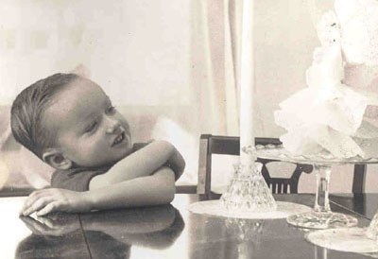

Age 4 with baby brother. 4½: With our beloved great-aunt Delia. Age 7, with brother
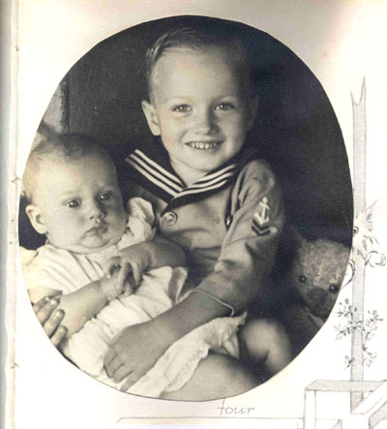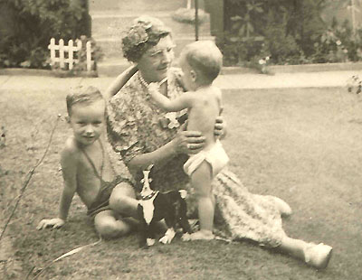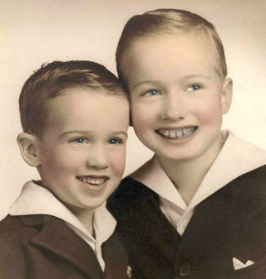

From Lynn’s career years:

L: Lynn at PARC just before going to DARPA; R: A wonderful memento given Lynn by DARPA’s leaders when she went to UM:
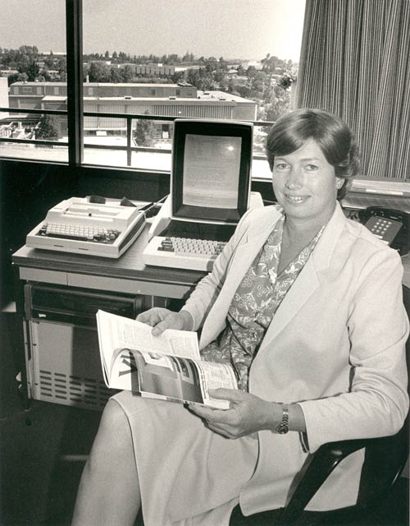

National War College, Fort McNair, Washington, DC: New members of the USAF SAB, 1987:
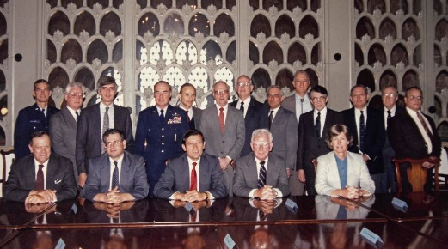

Members of the Board of Visitors of the US Air Force Academy get ready for some flying. [L-R]: Ambassador Fred Zeder, U.S. Rep. Pete Peterson (D-FL), U. S. Rep. John Tanner (D-TN), Prof. Lynn Conway, Gen. Brent Scowcroft; July 1996
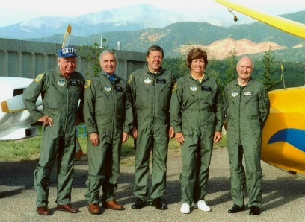

Lynn on a sentimental incognito-visit to MIT in the fall of 2008, 30 years after teaching her 1978 VLSI course there:

L: Cover of IEEE-SCCM special-issue about Lynn’s career, Fall 2012; R: Lynn and Brynn Tannehil at “Out To Innovate”, 2012:
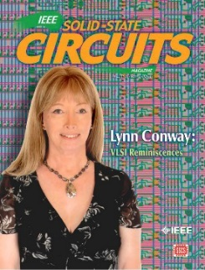
From Lynn’s adventure sports:

Whitewater canoeing and slalom racing:
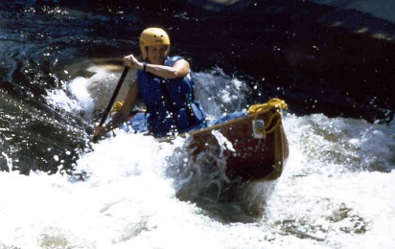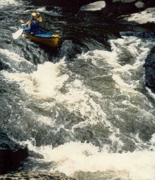

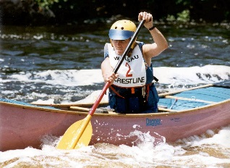

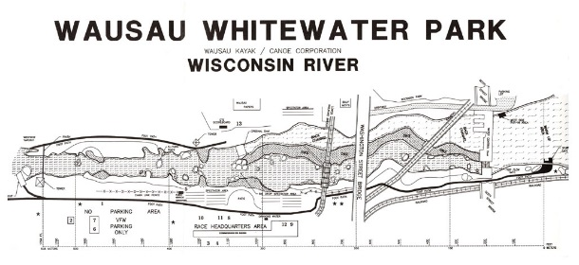

Motocross and supercross racing:
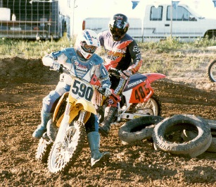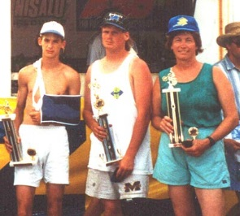

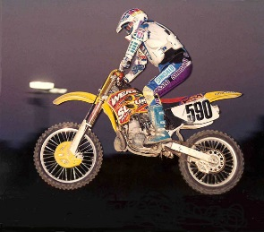

Lynn and Charlie: They’ve been together since 1988.

