Lynn's Adventuring
Transgender pioneer reflects on sports past
by Ross Forman, Windy City Times
September 18, 2013
Lynn Conway is a transgender pioneer whose longtime passion has been sports, particularly adventure sports. She's overcome two similar life obstacles (transitioning and a fear of heights) en route to her current state: a 75-year-old Michigan resident—reflective and respected, passionate and accomplished, innovative and intelligent.
"In a strange way, while rock-climbing years ago I was learning exactly what I needed to transition, learning how to overcome fear," Conway said. "Although scared of heights, I worked up to some modest climbing in Yosemite Valley—and passionately enjoyed it."
Conway, who lives west of Ann Arbor, has been married to Charlie since 2002; they have been together since 1988. The two were in Washington D.C., this past June for the President's White House Reception in celebration of LGBT Pride Month. Joy, hope and optimism carried throughout the event, filled with other activists, advocates and allies.
Conway has been out and a trans-rights advocate for 15 years, although her involvement with the LGBT community began decades earlier.
"When I went away to college in 1955, I was finally free to begin exploring—but it was very difficult," Conway said. "I thought I was gay [early on because] society was telling me I was. So I sort of randomly tried to find my way into the gay world, but that didn't work."
Enjoying sailing while in college, Conway was also drawn to rock climbing, finding joy in conquering her fear of heights a step at a time.
After earning her degrees at Columbia University in the early 1960s, Conway went west into a computer research career and into climbing in Yosemite and the Sierra Nevada. By then she knew what she had to do. She completed her transition in 1968 while living in San Francisco.
"Most of my transition mentors were trans-girls who were either sex workers or entertainers at places like Finnochio's," she said, reflecting on an era long past. "No way could I have been out back then and found a regular job. I didn't have the talent to be an entertainer, so I'd have ended up in sex work."
All along, sports were Conway's crutch, her supporting shoulder. The adventure sports were dangerous and difficult, but transitioning was as well. However, the sports were also exciting. "It's the learning that's fun, the exploring that's fun," she said.
Conway became a widely known computer pioneer while living in stealth after her transition. She also took up whitewater slalom racing and went on to motocross racing, sports that, no doubt, brought her back to summer camp, at age 10, in Maine.
"[Camp] was a transformative experience in my life because all at once I learned about things like making fires, hiking, camping, fishing, swimming, horseback riding, rifle shooting and more," Conway said. "It's what set off my tomboyish adventure-seeking."
Rock Climbing – Hiking and Backpacking – Physical Training – XC Skiing and Snowshoeing – 10K Running
Whitewater Canoeing and Slalom Racing – Motocross and Supercross Racing
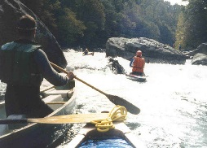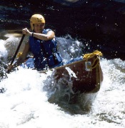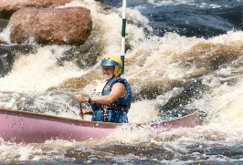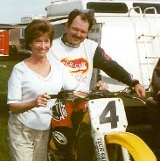
http://ai.eecs.umich.edu/people/conway/conway.html#Adventuring

