CHM Fellow Award:
Links to Online Documents and Videos

CHM Fellow Awards 2014:
https://www.youtube.com/watch?v=5VbDbMIypGU

Lynn Conway, A Life:
https://www.youtube.com/watch?v=m93bvIiCL-c
Lynn's Award Acceptance Speech:
https://www.youtube.com/watch?v=d0mBjP-gBik
http://ai.eecs.umich.edu/people/conway/Awards/CHM/Talk/What_Words_Can_We_Leave_to_Guide_Them.htm
http://ai.eecs.umich.edu/people/conway/Awards/CHM/Talk/What_Words_Can_We_Leave_to_Guide_Them.pdf

Lynn's CHM Bio:
http://www.computerhistory.org/fellowawards/hall/bios/Lynn,Conway/
Lynn's Oral History:
http://www.computerhistory.org/collections/accession/102746864
http://archive.computerhistory.org/resources/access/text/2014/05/102746864-05-01-acc.pdf

Photos of 2014 Fellow Awards Gala:
https://www.facebook.com/media/set/?set=a.10152388292430816.1073741857.132738745815

Attachments area
Preview YouTube video Computer History Museum: Fellow Awards 2014
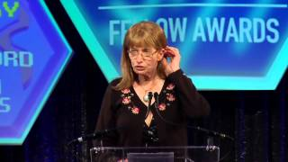
Preview YouTube video Computer History Museum 2014 Fellow Lynn Conway
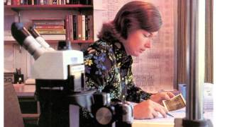
Preview YouTube video 2014 Fellow Lynn Conway
